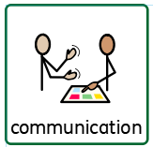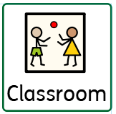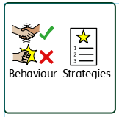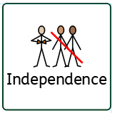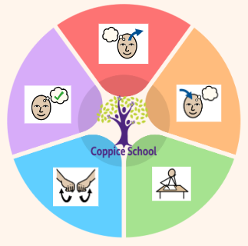

**Strand 1: Number Set 2**

**Red: With help pupil makes sets with one and with lots of objects**

**Yellow: Pupil demonstrates an understanding of the concept of more / less**

**Strand 2: Geometry Set 2**

**Red:** Pupil combines objects to make simple constructions

**Yellow:** Pupil manipulates 2D/3D shapes Pupil begins to build using 2D/3D shapes

**Strand 3: Measure**

Yellow: Explores making volumes ‘more and less’ and ‘full / empty’ and attends to adult modelling vocabulary.

**Strand 4: Data Handling**

To collect tokens to keep track of an event or game. To use their fingers to denote/tally small amounts to the value of 5.

**Composite Half Termly End Point:**

Red

Accept hand washing as part of my routine.

Accept putting on an apron as part of my routine.

Grasp finger foods and bring them to my mouth.

Handle and explore cooking tools with adult support.

Yellow

Follow instructions and prompts to turn on the tap.

Follow instructions and prompts to rub my hands with soap.

Follow instructions and prompts to put my hands under water to rinse them.

Put on my apron with adult prompts and support.

Explore mixing with physical support.

**Composite Half Termly End Point:**

Red: **Accept support from a familiar adult to try new activities and taker part. Seek a familiar adult to share emotions with such as Joy or sadness Show a range of emotions such as happy sad, excited, afraid.**

Blue: **Express my feelings in a non-aggressive manner. Recognize and name familiar and persistence emotions. Tolerate social interactions**

**Composite Half Termly End Point:**

Red: Explore and experiment with a range of media through sensory exploration and actions. Show an awareness of the purpose of familiar tools. Notice and show interest in the effects of making movements which leave marks.

**Yellow:** Match and group a range of colours, identifying if one is different.

Explore colour and mixing colours.

Make models using malleable media.

Select a tool for a purpose and communicate what it does (e.g. cut, stick).

**HCS**

**Coping**

**Geography**

**Composite Half Termly End Point:**

Red: Take turns and share spaces and adult attention when supported.

**Yellow:** Demonstrate sharing with peers in own class.

**Composite Half Termly End Point:**

Red: Tolerate and take part in care routines (e.g. hand massage.) Begin to responds to the word/ symbol Stop

Yellow: **Cooperate and respond positively to an adult when I am out in the community/ New environment.**

**Respond to the word Stop**

**RSE**

**Keeping Safe**

**MY WORLD**

**Health and well being**

**Composite Half Termly End Point:**

Red:

Explores plants and their textures by handling.

Observe changes in plants (leaves and trees moving in the wind.

Imitates and improvises actions they have observed e.g. watering the plants.

Yellow:

Explores plants independently, paying attention to cause and effect.

Begins to notice changes and differences in plants.

In role play uses plants/vegetables, shows an understanding of the purposes of tools linked to plants and vegetables.

**Composite Half Termly End Point:**

**Red**

Show awareness of the sun. Show awareness in the changes in the weather. Notices changes in temperature, sound or light. Notice and draw attention to things outside e.g. rain / flowers/ aeroplane.

Yellow

Observes the weather.

Notices and begins to comment on changes/effects outside e.g. trees, seasons.

Notices and begins to comment on sounds outside.

Recognise rain, puddles and ice.

**Books:**

· · Supertato – Sue Hendra · Jack & The Beanstalk -Mara Alperin

· The Secret Sky Garden – Linda Sarah · Little Red Hen – Mary Finch

**Composite Half Termly End Point:**

Red: Try or explore (using different senses) a range of familiar foods with different consistencies and textures, and begins to show preferences. Wash my hands and face with support.

Yellow: Attempt to brush my own hair and teeth. Try or explore a range of foods, familiar and non-familiar. Begins to wash hands and his own face.

**Composite Half Termly End Point:**

**Art**

***To support pupils to have a voice we will use…***

***PECS, Communication boards,***

***Communication books,***

***Makaton, gesture and body language cues.***

***In our learning environment, displays and provision we are trying to support and facilitate the following knowledge and skills; Independence, coping, self-regulation, tolerance of others, building positive relationships, communication and confidence.***

***To support behaviours in our class you will see the following strategies: redirecting, distraction methods, modelling and supporting with key words.***

**Communication Half Termly End Point:**

**Red:**

**Understanding- Respond appropriately to simple requests such as ‘clap your hands.’**

**Listening- *Identifies the correct object by sound e.g. points to dog when ‘woof’ is said.***

***Communicating- Use sounds in play e.g. aahh when cuddling a toy or brrm with a car.***

**Yellow**

**Listening** - Attempt to copy new sounds or words.

**Understanding- Understand up to 10 verbs.**

**Communicating - With help communicate about things that have happened or will happen.**

**MATHS**

**RE**

**Charity**

**Science**

**Plants**

***To support pupils to develop independence we encourage…***

***Daily personal hygiene routines, encourage pupils to tidy away and help find resources.***

**DT**

**Strand: My cooking**

**Class Focus:**

*Independence*

**Class:** *Rowan class*

**Pathway:** *Informal/ Semi-Formal*

**Term***: Summer*

**Theme:**

**Funny faces and Fabulous Features**

**ENGLISH**

**Class Focus:**

**Superato**

**Cognition & Learning**

**Social, Emotional & Mental Health**

**Communication & Interaction**

**Physical & Sensory**

**Developing Independence**

**PSHE**