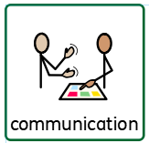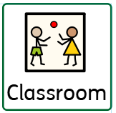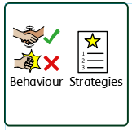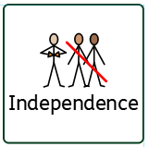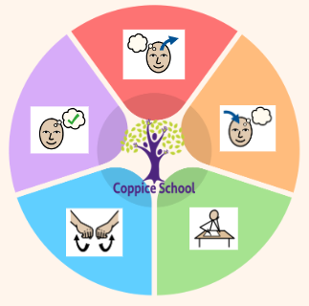

**Composite Half Termly End Point:**

Red: Explore new toys and environments, returning for reassurance (checking in) when needed. Show an interest in toys with buttons, flaps and simple mechanisms and try to operate them. Engage other people to help achieve a goal

Yellow: Explore objects by linking together different approaches Seek out others to share experiences. Respond to a few appropriate boundaries with encouragement and support.

**Composite Half Termly End Point:**

Red: Observe and show interest as people move around Enjoy pictures and stories about myself, my family and other people Recognise and show interest in familiar environments

Yellow: Communicate about myself and people

I know using pictures/photo

**Composite Half Termly End Point:**

Red: Explore objects and media linked to different careers. Observe and begin to respond to adult play linked to jobs/careers.

Yellow: Take part in activities that link to do different careers. Respond to adult play linked to jobs/careers.

**Books:** Georges Marvellous Medicine

The Artist, The Lines on Nana’s Face

Ciraolo

**Composite Half Termly End Point:**

**Composite Half Termly End Point: Sp2**

Red: Make deliberate marks using a variety of tools and media on different backgrounds e.g. chalkboard, whiteboard, paper etc.

Yellow: Imitate drawing circles and lines.

Experiment with a range of painting techniques i.e. splatter painting.

Use a palmer grasp to begin to make circles and straight lines.

**Composite Half Termly End Point:**

Red: Move along paths. Show some awareness of obstacles. Respond to up and down by body movement with prompts. Demonstrate an awareness of the gradient of the ground.

**Yellow:** Respond to up and down by body movement. Repeat activity to refine skill. Demonstrate an awareness of some basic concepts - big and small ball, big and small steps. Collect familiar pieces of equipment. Complete a task ensuring that both hands work together. Crawl through a tunnel Travel up and down a slid

**Composite Half Termly End Point:**

Red: Explore new toys and environments, returning for reassurance (checking in) when needed. Show an interest in toys with buttons, flaps and simple mechanisms and try to operate them. Engage other people to help achieve a goal

Yellow: Explore objects by linking together different approaches Seek out others to share experiences. Respond to a few appropriate boundaries with encouragement and support.

**Composite Half Termly End Point:**

Red: Explore and experiment with a range of food using my whole body.

Accept a variety of textures

Explore different foods independently paying attention to what happens next

Yellow: Show willingness to try new food textures and tastes.

Remember that some actions are important or exciting (e.g. pouring juice.)

Demonstrate use and function of familiar foods.

**Strand 1: Number Set 1**

**Red: Pupil indicates one object. Pupil indicates 2 objects.**

**Yellow: Pupil creates sets to three**

**Pupil counts five objects by touching one at a time, arranged in a line and randomly – including 1p coins**

**Strand 2: Geometry Set 3**

**Red: Pupil searches for and finds objects in their usual place or when they have moved out of sight.**

**Yellow: Pupil begins to respond to instructions containing positional words, signs or symbols – in, on, over, under, inside, outside, top, bottom.**

**PE**

**RSE Relationships**

**Composite Half Termly End Point:**

Red: Take a few turns in a game with support. Accept interaction with another person (e.g. give and receive an object.)

Yellow: Show an interest in other’s play and begin to join in. Tolerate being part of a small group.

***To support pupils to have a voice we will use…***

***PECS, Communication boards,***

***Communication books,***

***Makaton, gesture and body language cues.***

***In our learning environment, displays and provision we are trying to support and facilitate the following knowledge and skills; Independence, coping, self-regulation, tolerance of others, building positive relationships, communication and confidence.***

***To support behaviours in our class you will see the following strategies: redirecting, distraction methods, modelling and supporting with key words.***

**Composite Half Termly End Point:**

Red: Begin to use yes and no.

Yellow: Follow simple meditation activities. Demonstrate a basic understanding of an action they do which is wrong or right e.g. helping to tidy up, breaking a toy. Match emotion names to images.

**Composite Half Termly End Point:**

Red: Imitates and improvises actions they have observed. E.g. mouth movements.

Yellow: Points to more complex body parts

**Communication Half Termly End Point:**

**Red:**

**Understanding- Demonstrate an understanding of 10-20 familiar words, pictures or signs.**

**Listening- Identifies the correct object by sound e.g. points to dog when ‘woof’ is said.**

**Communicating- Use sounds in play e.g. aahh when cuddling a toy or brrm with a car.**

**Yellow**

**Listening** - Attempt to copy new sounds or words.

**Understanding- Understand up to 10 verbs.**

**Communicating - With help communicate about things that have happened or will happen.**

**MATHS**

**RE**

**Peace**

**Science**

**Art**

***To support pupils to develop independence we encourage…***

***Daily personal hygiene routines, encourage pupils to tidy away and help find resources.***

**History**

**HCS**

**DT**

**Strand: My cooking**

**Class Focus:**

*Independence*

**Class:** *Rowan class*

**Pathway:** *Informal/ Semi-Formal*

**Term***: Spring 2*

**Theme:**

**Funny faces and Fabulous Features**

**MY WORLD**

**ENGLISH**

**Class Focus:**

**Cognition & Learning**

**Social, Emotional & Mental Health**

**Communication & Interaction**

**Physical & Sensory**

**Developing Independence**

**PSHE**