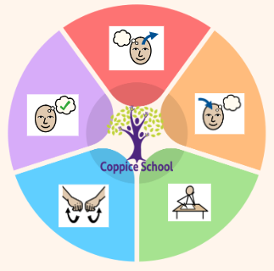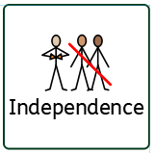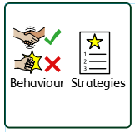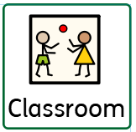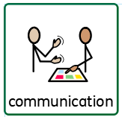

***In our learning environment, displays and provision we are trying to support and facilitate the following knowledge and skills;*** *independent child-initiated mark making, touch counting with correspondence to ten and beyond*

**Science**

**Strand: Human Body**

**Books:**

**The Artist**

**The Lines on Nana’s Face**

**Class:**Oak

**Pathway:** Semi-formal

**Term***:* Spring 2

**DT**

**Strand: My Cooking**

**ART**

**Strand: 2D**

**RE**

**HISTORY**

**Strand: Changes**

**ENGLISH**

**MATHS**

1. **Measure**
2. **Time**

***To support pupils to develop independence we encourage…***

*Self-dressing, toileting, teeth brushing, hair brushing*

***To support behaviours in our class you will see the following strategies:*** *Countdowns, PECs, strong routines, modelling of positive behaviours from adults*

**Cognition & Learning**

**Social, Emotional & Mental Health**

**Communication & Interaction**

**Physical & Sensory**

**Developing Independence**

**RSE**

**MY WORLD**

**PSHE**

**Theme:**

**Funny Faces & Fabulous Features**

**Communication Half Termly End Point:**

**Yellow: Understand concepts e.g. big/little.**

**Blue: Understand the language of same and different.**

**Green: Begin to think of simple alternatives of vocabulary choice.**

**Reading Half Termly End Point:**

**Yellow: Match objects to pictures and symbols.**

**Blue: Ascribe meaning to marks I see in different places e.g. recognise McDonalds logo.**

**Green: Recognise predictable or repeated phrases.**

**Writing Half Termly End Point:**

**Yellow: Draw lines and circles.**

**Blue: Represent my own name with marks.**

**Green: Write my own name and other things such as labels or captions.**

**Strand 1:**

**Half Termly End Point:**

**Yellow: Selects the ‘heavy / light’, ‘full / empty’ Selects items of approximately ‘the same’ weight.**

**Blue: Begins to order objects by weight using direct comparison.**

**Green: Begin to know the doubles of numbers up to 10**

**Strand 2:**

**Half Termly End Point:**

**Yellow: Responds to vocabulary ‘before / after / next / last’.**

**Blue: Uses simple time vocabulary e.g. play time, dinner time, home time.**

**Green: Compare time (quicker, slower, earlier, later)**

**Composite Half Termly End Point:**

**Yellow: Understand that some language about immediate past and future e.g. later**

**Blue: Add a caption or a label to a familiar picture or person.**

**Green: Write a short caption for an illustration.**

**Composite Half Termly End Point:**

**Yellow: Explore colour and mixing colours.**

**Blue: Create simple representations of people.**

**Green: Draw lines of varying thickness, use dots and lines to demonstrate pattern and texture.**

**Composite Half Termly End Point:**

**Yellow: Explore objects using their senses.**

**Blue: Sequence a life cycle of a human with at least three pictures.**

**Green: Can talk about the changes over time from babies to adults, by looking at photographs.**

**Composite Half Termly End Point:**

**Yellow: Demonstrate use and function of familiar foods.**

**Blue: Begin to be interested in and describe the textures and tastes of foods.**

**Green: Heat food and recognise change.**

**PE**

**Strand: Outdoor Adventurous Activities**

**Composite Half Termly End Point:**

**Yellow: Demonstrate a basic understanding of an action they do which is wrong or right e.g. helping to tidy up, breaking a toy.**

**Blue: Demonstrate a basic understanding of what is right and wrong in familiar situations, evaluating own actions and begin to understand consequences.**

**Green: Demonstrate an understanding of what is right or wrong in day to day situations and stories.**

**Composite Half Termly End Point:**

**Yellow: Demonstrate an awareness of some basic concepts - big and small ball, big and small steps.**

**Blue: Climb up and down equipment with control.**

**Green: Use imaginative ways to express and explore and communicate ideas, solve problems and overcome challenges.**

**Composite Half Termly End Point:**

**Yellow: Take part in activities that link to do different careers.**

**Blue: Identify some simple ways in which certain jobs can take care of people / animals / the environment.**

**Green: Identify some jobs which I enjoy doing.**

**Composite Half Termly End Point:**

**Yellow: Show an interest in other’s play and begin to join in.**

**Blue: Confidently interact with other children when playing.**

**Green: Understand that we shouldn’t share private and personal information with strangers.**

***To support pupils to have a voice we will use…***

*PECs, communication books, Makaton, choices*