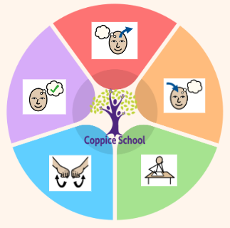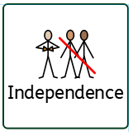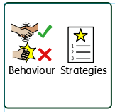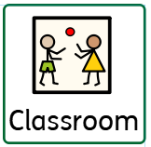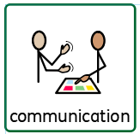

**Communication Half Termly End Point:**

**Yellow: Pupil uses words to describe things e.g. ‘it is bumpy.’**

**Blue: Pupil retells simple stories to others.**

**Green: Pupil gives descriptions and explanations.**

**Reading Half Termly End Point:**

**Yellow: Pupil recognises own name with a picture clue.**

**Blue: Pupil links sounds to letters, naming and sounding the letters of the alphabet.**

**Green: Pupil expresses an opinion about a story/ character.**

**Writing Half Termly End Point:**

**Yellow: Pupil dictates a caption for a picture.**

**Blue: Pupil chooses to write independently.**

**Green: Pupil puts regular spaces between words.**

**Composite Half Termly End Point:**

**Yellow: Pupil responds to interactive rhymes.**

**Blue: Pupil joins in with dancing and ring games.**

**Green: Pupil walks/moves to a pulse.**

**Composite Half Termly End Point:**

**Yellow: Pupil explores media by linking together different approaches such as: threading and sticking.**

**Blue: Pupil uses simple tools and techniques to achieve a planned effect.**

**Green: Pupil purposefully selects and uses the most appropriate hand tool for a specific purpose.**

**Composite Half Termly End Point:**

**Yellow: Pupil is beginning to use more complex actions e.g. twisting, tearing, folding, turning materials.**

**Blue: Pupil understands that different materials and media can be combined to create new effects.**

**Green: Pupil finds out how the shapes of solid objects made from some materials can be changed by squashing, bending, twisting and stretching.**

**Strand 1:**

**Half Termly End Point:**

**Yellow: Pupil begins to compare sets to identify more/less or bigger group/smaller group.**

**Blue: Pupil begins to use the vocabulary “add” and “take away” in practical situations.**

**Green: Pupil reads, writes and interprets the symbols +, - and = appropriately.**

**Strand 2:**

**Half Termly End Point:**

**Yellow: Pupil begins to pick out named shapes from a collection.**

**Blue: Pupil counts the number of corners, sides and faces of everyday objects.**

**Green: Pupil uses everyday language to compare and sort 2D and 3D shapes.**

**Composite Half Termly End Point:**

**Yellow: Pupil uses some large apparatus with some control.**

**Blue: Pupil attempts a pencil and egg roll.**

**Green: Pupil performs a variety of jumps and lands safely using the correct technique.**

**Composite Half Termly End Point:**

**Yellow: Pupil shows that they recognize their own immediate family and relations.**

**Blue: Pupil communicates about and shows an awareness of the similarities and differences in relation to their friends or family.**

**Green: Pupil explains how and why we need to look after our school environment, and play an active part in looking after it.**

**Composite Half Termly End Point:**

**Yellow: Pupil begins to understand that other people have needs and to respect these.**

**Blue: Pupil treats living things and their environment with care and concern.**

**Green: Pupil uses some religious words and phrases to recognise and name features of religious life and practice.**

**RSE**

**Relationships, families**

**Books:**

**The Proudest Blue, The Best Diwali Ever, Santa’s New Beard**

**ENGLISH**

**Class Focus: Lost and Found**

***In our learning environment, displays and provision we are trying to support and facilitate the following knowledge and skills; Turn taking, sharing, waiting/ patience, imaginative play, positive relationships***

***To support pupils to have a voice we will use…***

***Signs, symbols, picture cues, PECs, communication strips/books***

**Class:*****Oak***

**Pathway*: Semi-formal***

**Term***:* ***Autumn 2***

**Composite Half Termly End Point:**

**Yellow: Pupil names or identifies people who are special to them.**

**Blue: Pupil communicates about their home and family.**

**Green: Pupil understands that families are made up of a special group of people and that this changes over time.**

**PE**

**Strand: Gymnastics**

**DT**

**Strand: Materials**

**RE**

**MUSIC**

**Science**

**Strand: Materials**

**MATHS**

***To support pupils to develop independence we encourage…***

***Tidying up, choosing from a limited range, self-dressing***

***To support behaviours in our class you will see the following strategies:***

***Now and next sentence stems, 5 second count down, embedded routines and structure***

**Cognition & Learning**

**Social, Emotional & Mental Health**

**Communication & Interaction**

**Physical & Sensory**

**Developing Independence**

**MY WORLD**

**PSHE**

**Theme:**

**Cultural Celebrations**