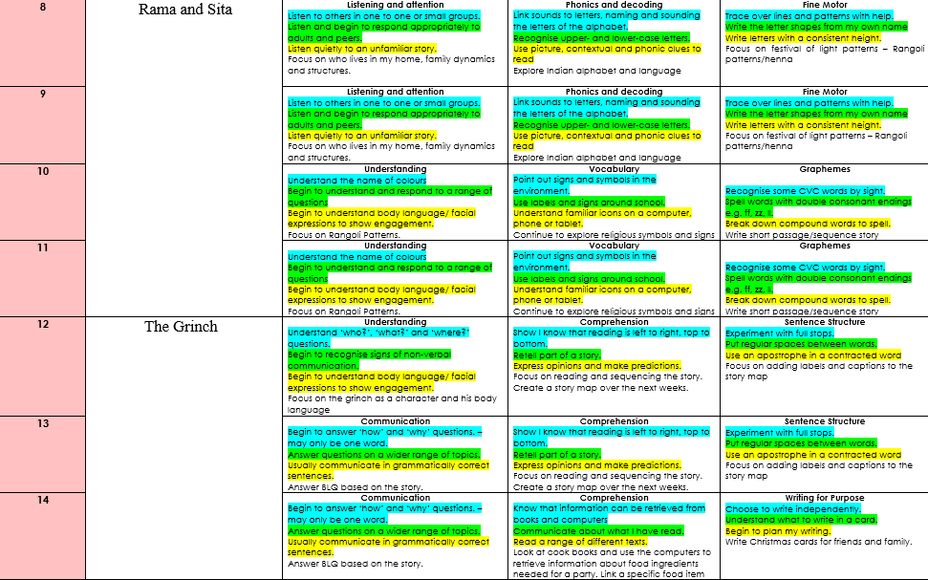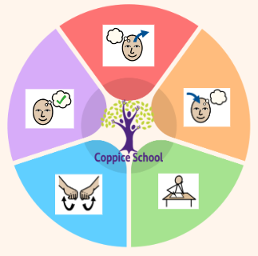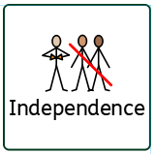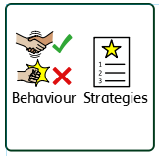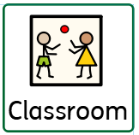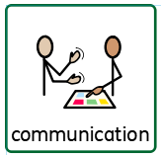

**ENGLISH**

**Class Focus: See table**

**Composite Half Termly End Point:**

**Blue:** Identify ingredients needs for a curry, Make a curry as independently as possible

**Strand 1: Geometry set 1 &3**

**Blue:** Pupil can name the 3D shapes cube, sphere, cone, cuboid.

**Green:** Identify and recognise common 3-D shapes, including cube

**Orange:** Read and write names for shapes. **Strand 2: Number set 2**

**Blue:** With an adult prompt, pupil can combine two small sets and count the total

**Green:** count in multiples of 2’s, 5’s and 10’s.

**Orange:** count in steps of 2,3 and 5 from 0, and in 10s from any number forward and backward.

**Strand 3: Data handling set 1**

**Blue:** To begin to understand the use of sorting/sets within practical contexts e.g. sorting a set of spoons to eat pudding, a set of colour crayons etc.

**Green:** read numerical information from lists.

**Orange:** Extract information from lists, tables, diagrams and bar charts

**DT**

**Strand:** Materials

**Class Focus:** Creating an outfit

**DT**

**Strand:** Cooking

**Class Focus:** Creating a curry

**Composite Half Termly End Point:**

**Blue:** To know that design is a way of planning our idea before we start

To know that threading is putting one material through another.

**Composite Half Termly End Point:**

**Blue:** Repeat a series of combined actions.

**Green:** To develop my understanding of the importance of daily exercise.

**Composite Half Termly End Point:**

**Blue:** Identify who is in my family

**Green:** Identify the people who love and care for me and how they help me feel cared for

**Orange:** Understand that all families vary and that no family is the same

***To support pupils to develop independence we encourage…***

Personal care, walking to the local community to purchase snacks

***To support pupils to have a voice we will use…***

Communication books, PECS, now and next, communication boards

**Books: Rama and Sita, The grinch, Wonder**

**MUSIC**

**Class Focus: To tap out and copy simple rhymths and beats. To understand how music makes us feel.**

**MY WORLD**

**Composite Half Termly End Point:**

**Blue:**Communicate about and show an awareness of the similarities and differences in relation to my friends or family.

**Green:**Identify and explain similarities and differences between myself and others.

**Orange:** Understand why and show that I can treat people with respect and kindness, regardless of our differences.

**Composite Half Termly End Point:**

**Blue:** Treat living things and their environment with care and concern.

**Green:** Be aware of my own influence on events and other people

**Orange:** Discover some similarities and differences between people in my school community

**Science**

**Strand:** Materials

**Class Focus:** Testing materials suitable for an outfit

**Composite Half Termly End Point:**

**Blue:** Understand that different materials and media can be combined to create new effects.

**Green:** Understand that different materials and media can be combined to create new effects.

**Composite Half Termly End Point:**

**Blue:** Tap out simple repeated rhythms.

Follow an instruction with 3 key words (e.g. shake the bells twice.)

Show a preference for a piece of music that represents spiritual, cultural or religious experiences.

**Green:** Join in call and response songs and rhythms, Hold simple instruments appropriately.

Walk/move to a pulse. Communicate how a piece of music can make me feel.

**PE**

**Strand:** Gymnastics

**RE**

**MATHS**

***To support behaviours in our class you will see the following strategies:*** Planned ignore, sand timers, now and next, working for strips,

**Class:** *J3*

**Pathway:** Semi-formal

**Term***: A2*

***In our learning environment, displays and provision we are trying to support and facilitate the following knowledge and skills;*** Phonics, a love for reading, zones of regulation and working walls.

**Cognition & Learning**

**Social, Emotional & Mental Health**

**Communication & Interaction**

**Physical & Sensory**

**Developing Independence**

**RSE**

**PSHE**

**Theme:**

**My Colourful World**