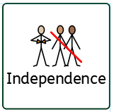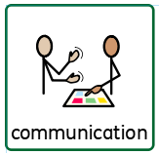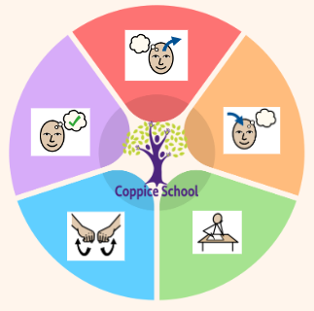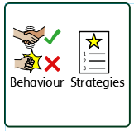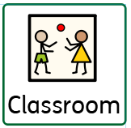

**PE**

**Strand:** Gymnastics

**Strand 2: Number Set 2**

**Half Termly End Point:**

**Blue:** With an adult prompt, pupil can combine two small sets and count the total

Pupil begins to use the vocabulary “add” and “take away” in practical situations

**Green:** count in multiples of 2’s, 5’s and 10’s.

**Orange:** count in steps of 2,3 and 5 from 0, and in 10s from any number forward and backward.

**Strand 3: Data Handling Set 1**

**Half Termly End Point:**

**Blue:** To begin to understand the use of sorting/sets within practical contexts e.g. sorting a set of spoons to eat pudding, a set of colour crayons etc.

**Green:** read numerical information from lists.

make a relevant pictogram using pictures of objects

**Orange:** extract information from lists, tables, diagrams and bar charts

make numerical comparisons from bar charts

**Composite Half Termly End Point:**

**Blue:** Treat living things and their environment with care and concern.

**Green:** Be aware of my own influence on events and other people

**Orange**: Discover some similarities and differences between people in my school community

**Composite Half Termly End Point:**

**Blue:** To know that design is a way of planning our idea before we start

To know that threading is putting one material through another.

**Composite Half Termly End Point:**

**Blue:** Tap out simple repeated rhythms.

Follow an instruction with 3 key words (e.g. shake the bells twice.)

Show a preference for a piece of music that represents spiritual, cultural or religious experiences.

**Green:** Join in call and response songs and rhythms

Hold simple instruments appropriately.

Walk/move to a pulse.

Communicate how a piece of music can make me feel.

**RSE**

**Composite Half Termly End Point:**

**Blue:** Identify who is in my family

Communicate about my home and family

**Green:** Identify the people who love and care for me and how they help me feel cared for

**Composite Half Termly End Point:**

**Blue:** Communicate about and show an awareness of the similarities and differences in relation to my friends or family.

**Green:** Identify and explain similarities and differences between myself and others.

**Orange:** Understand why and show that I can treat people with respect and kindness, regardless of our differences.

**MY WORLD**

**Composite Half Termly End Point:**

**Blue:** Identify ingredients needs for a curry.

Make a curry as independently as possible

**Composite Half Termly End Point:**

**Blue:** Repeat a series of combined actions.

**Green:** To develop my understanding of the importance of daily exercise.

**Composite Half Termly End Point:**

**Blue:** Understand that different materials and media can be combined to create new effects.

**Green:** Find out how the shapes of solid objects made from some materials can be changed by squashing, bending, twisting and stretching.

**RE**

**DT**

**Strand:** Materials

**Class Focus:** Planning/Designing and sewing

**MUSIC**

**Class Focus:** Tapping out simple rhythms and understanding how music makes us feels

**ENGLISH**

**Class Focus:** *Rama and Sita/ The Grinch who Stole Christmas*

*(see overview)*

**DT – My Cooking**

**Class Focus:** Food safety, chopping, preparing

**Books:**

**Salat in Secret, Pattans Pumpkin, Matilda**

***To support pupils to have a voice we will use…***

*communication boards, PECS, Makaton, simple language, sentence strips, communication books*

***To support pupils to develop independence we encourage…***

*Collect own resources with PECS, personal care, drinks station, independent changing - swimming and PE*

**Science**

**Strand:** Materials

**Class Focus:** knowing which materials are suitable for an outfit

**Class:** *J1*

**Pathway:** Semi-Formal

**Term***: Autumn 2*

***To support behaviours in our class you will see the following strategies:***

*Deep pressure, timers for reflection time, movement breaks, change of face, planned ignoring where needed, team teach, firm voices.*

***In our learning environment, displays and provision we are trying to support and facilitate the following knowledge and skills;***

*Communication, exploring new activities, phonics and maths skills, independence, self-regulation, love of reading.*

**MATHS**

**Cognition & Learning**

**Social, Emotional & Mental Health**

**Communication & Interaction**

**Physical & Sensory**

**Developing Independence**

**PSHE**

**Theme:**

**Cultural Celebrations**