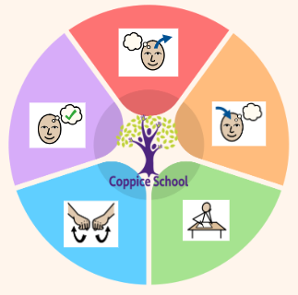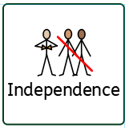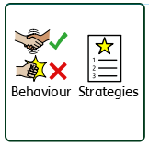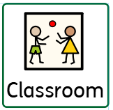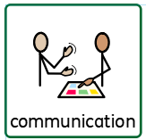/Formal **Yellow**

**Communication Half Termly End Point:**

**Yellow: Understand simple sentences such as ‘throw the ball’. Understand what objects are used for e.g. hair brush, by putting brush on head. Is beginning to understand ‘what?’ Find a named picture within a picture.**

**Blue: Fetch 3 objects on request with a visual cue. Understand the name of colours. Show an understanding of prepositions such as; on top, under, behind. Understand ‘who?’, ‘what?’ and ‘where?’ questions.**

**Reading Half Termly End Point:**

**Yellow: Recognise familiar symbols/objects. Match identical symbols. Recognise my name with a picture clue.**

**Blue: Point out signs and symbols in the environment.**

**Writing Half Termly End Point:**

**Yellow: Point index or one finger as a part of communicating. Follow a route on a road map or track. Manipulate magnetic letters. Use a computer program to make marks.**

**Blue: Copy my name with physical help. Trace over lines and patterns with help. Trace over letters with support. Give meaning to the marks that I draw, paint or write.**

**Composite Half Termly End Point:**

**Yellow:** Begin to categorise objects according to their property

**Blue:** Understand that different materials and media can be combined to create new effects.

**Orange:** Compare and group together objects according to their properties

**Composite Half Termly End Point:**

**Yellow:** Begin to understand that other people (and animals) have needs and to respect these

**Blue:** Treat living things and their environment with care and concern.

**Orange:** Discover some similarities and differences between people in my school community

**Composite Half Termly End Point:**

**Yellow:** Copy an adult’s action once shown (e.g. bang on a drum.

**Blue:** Tap out simple repeated rhythms.

Follow an instruction with 3 key words (e.g. shake the bells twice.)

Show a preference for a piece of music that represents spiritual, cultural or religious experiences.

Orange: Tap a pulse rhythm while listening to a piece of music

**Strand 1: Geometry set 1&3**

**Yellow:** Pupils begin to pick out named shapes from a collection.

**Blue:** Pupil can name the 3D shapes cube, sphere, cone, cuboid.

**Orange:** Read and write names for shapes.

**Strand 2: Number set 2**

**Yellow:** Pupil manipulates 2D/3D shapes

**Blue:** With an adult prompt, pupil can combine two small sets and count the total

**Orange:** Count in steps of 2,3 and 5 from 0, and in 10s from any number forward and backward.

**Strand 3: Data handling set 1**

**Yellow:** Pupil begins to compare sets to identify more/less or bigger group/smaller group

**Blue:** With an adult prompt, pupil can combine two small sets and count the total

**Orange:**: Extract information from lists, tables, diagrams and bar charts

**Composite Half Termly End Point:**

**:Blue:** Repeat a series of combined actions

**Orange:** To develop my understanding of the importance of daily exercise.

**Composite Half Termly End Point:**

**Yellow:** Use simple tools and techniques to achieve a planned effect.

**Blue:** Use simple tools and techniques to achieve a planned effect.

**Composite Half Termly End Point:**

**Yellow:**

**Blue:** Identify ingredients needs for a curry, Make a curry as independently as possible

**DT**

**Strand:** Materials

**Class Focus:** Creating a puppet

**DT**

**Strand:** Cooking

**Class Focus:** Creating a curry

**Composite Half Termly End Point:**

**Yellow:** Name or identify people who are special to me

**Blue:** Identify who is in my family

**Orange:** Understand that all families vary and that no family is the same.

***To support pupils to develop independence we encourage…***

Personal care, walking to the local community to purchase snacks

***To support pupils to have a voice we will use…***

Communication books, PECS, now and next, communication boards

**Books: The Proudest blue**

**The Best Diwali Ever, Santa’s New Beard**

**MUSIC**

**Class Focus: To tap out and copy simple rhythm and beats. To understand how music makes us feel.**

**MY WORLD**

**Composite Half Termly End Point:**

**Yellow:** Respond to pictures and stories about myself, my family and other people.

**Blue:**Communicate about and show an awareness of the similarities and differences in relation to my friends or family.

**Orange:** Understand why and show that I can treat people with respect and kindness, regardless of our differences.

**Science**

**Strand:** Materials

**Class Focus:** Testing materials suitable for an outfit

**PE**

**Strand:** Gymnastics

**RE**

**ENGLISH**

**Class Focus: See table**

**MATHS**

***To support behaviours in our class you will see the following strategies:*** Planned ignore, sand timers, now and next, working for strips,

**Class:** *Hazel*

**Pathway:** Semi-formal/Formal

**Term***: A2*

***In our learning environment, displays and provision we are trying to support and facilitate the following knowledge and skills;*** Phonics, a love for reading, zones of regulation and working walls.

**Cognition & Learning**

**Social, Emotional & Mental Health**

**Communication & Interaction**

**Physical & Sensory**

**Developing Independence**

**RSE**

**PSHE**

**Theme:**

**My Colourful World**