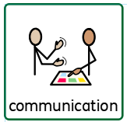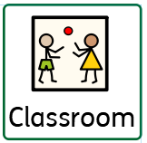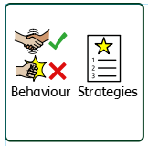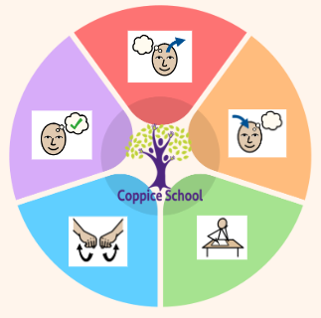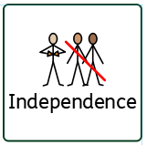

**Half Termly End Point: number set 2**

**Red:** Pupils interacts with familiar number rhymes and songs

Pupil experiences 1:1 correspondence in everyday situations

Pupil touches, observes or gazes at objects one at a time as adult counts

**Yellow**: Pupil participates in number activities reciting numbers one to five and may use fingers to identify numbers.

Pupil creates sets to three Pupil counts five objects by touching one at a time, arranged in a line and randomly – including 1p coins

**Communication Half Termly End Point:**

**Pink:**

**Red**:

**Yellow**:

**:**

***To support pupils to have a voice we will use…body gesture, facial gesture, PECS- symbols and boards, Makaton, behavioural expression***

**MUSIC**

**Strand: Cultural sounds**

**Class Focus: responding to different music**

**ENGLISH**

**Class Focus: developing effective communication**

**PE**

**Strand: gymnastics and fitness**

**Composite Half Termly End Point:**

**Pink:** Crawl, roll, slide on stomach, wriggle on stomach and bear walk. Move forwards and backwards when crawling

**Red:** Climb on and off low equipment. Attempt to jump off low equipment. Perform a Single jump two feet together. Perform a squat and rise from squat using hands. Climb on and off objects. Climb over objects. Climb on a small climbing frame with support.

**Yellow:** Stand on one foot for a second. Creep on toes. Walk safely between mats and markers. Use some large apparatus with some control. Use some small apparatus with some control. Walk along wide bench with assistance. Jump sideways two feet together. Climb on a small climbing frame.

**Composite Half Termly End Point:**

**Red: Use scissors to make snips into soft stationary media**

**Remember actions and preferences**

Handle and explore tools with adult support.

**Yellow: Use scissors to cut taut fabric at random**. **Explore media by linking together different approaches such as: threading and sticking**

Show control in holding and using equipment and tools

**Class:** *Rowan*

**Pathway: Informal**

**Term***: Autumn 2 ‘24*

**Composite Half Termly End Point:**

**Pink:** Control my hands

Reach out for, touch and begin to hold objects

**Red:** Explore different instruments spontaneously and independently

Imitate actions of an adult

with actions

**Yellow:** Create sounds by banging, shaking, tapping or blowing

Copy an adult’s action once shown

Respond to interactive rhymes

***In our learning environment, displays and provision we are trying to support and facilitate the following knowledge and skills; independence, sharing and cooperation, understanding, tolerance, acceptance***

***To support behaviours in our class you will see the following strategies: sensory diet, therapies, movement, appropriate demands, child-initiated learning, processing time***

**Composite Half Termly End Point:**

**Pink:** Explores objects by looking, touching and mouthing Repeats an action that has an effect **Red:** Explore new and different materials with adult support. Explore objects intentionally, by investigating cause and effect. Begin to notice some similarities and differences **Yellow:** Can use words, signs or symbol to describe a material. Beginning to categorise objects according to property e.g. size, colour. Is beginning to use more complex actions.

**Blue:**

**Composite Half Termly End Point:**

**Red:** Observes and show interest as people move around Begin to respond to the feelings of others, for example, matching their emotions and laughing when another pupil is laughing.

**Yellow:** Take part in activities involving two or three other learners. Begin to understand that other people have needs and to respect these

***To support pupils to develop independence we encourage…Personal care, hygiene, feeding, preparation of food, dressing and trips within the community***

**Composite Half Termly End Point:**

**Red:** Play cooperatively with a familiar adult (e.g. rolling a ball back and forth). Build relationships with people that are special to me

**Yellow:** Share new experiences with familiar adults Name or identify people who are special to me

**Composite Half Termly End Point:**

**Pink:** Recognise the faces and voices of familiar significant people.

**Red:** Show curiosity about people and an interest in stories about myself and my family. Demonstrate immediate recognition of familiar adults. Observe and show an interest as people move around me

**Yellow:** Show that I recognize my own immediate family and relations. Respond to pictures and stories about myself, my family and other people Have an awareness of my similarities and differences in relation to my family and friends.

**MATHS**

**Class focus:**

**Using math skills in meaningful ways**

**Rama & Sita**

**The Grinch Who Stole Christmas**

**DT**

**Strand: Textiles**

**Class Focus: developing fine motor skills using different tools**

**Science**

**Strand: Materials**

**Class Focus: exploring different textures**

Begin to notice some similarities and differences

**RE**

**Theme:**

**Cultural Celebrations**

**Cognition & Learning**

**Social, Emotional & Mental Health**

**Communication & Interaction**

**Physical & Sensory**

**Developing Independence**

**RSE**

**MY WORLD**

**PSHE**