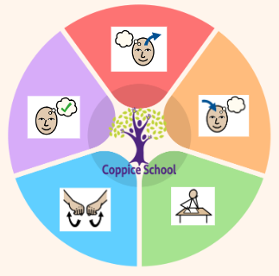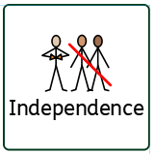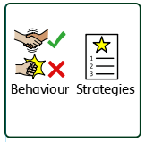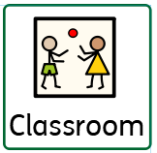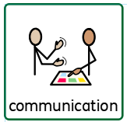

**Composite Half Termly End Point:**

**Yellow: Create: stitching & threading Explore media by linking together different approaches such as: threading and sticking**

**Blue: Create: stitching & threading Make a stitch by pushing and pulling needle and thread through fabric.**

**Composite Half Termly End Point:**

**Yellow: Understands that different materials and media can be combined to create new effects**

**Blue: Is beginning to use more complex actions e.g. twisting, tearing, folding, turning materials.**

**Composite Half Termly End Point:**

**Yellow: Copy an adult’s action once shown (e.g. bang on a drum.**

**Blue: Follow an instruction with 3 key words (e.g. shake the bells twice.**

**Composite Half Termly End Point:**

**Yellow: Stand on one foot for a second. Creep on toes. Walk safely between mats and markers. Use some large apparatus with some control. Use some small apparatus with some control. Walk along wide bench with assistance.**

**Blue: Run on my toes. Attempt a pencil and egg roll. Walk along a line, bench and beam. Stop and start with some accuracy. Skip and hop on with one foot. Balance on different parts of the body. Repeat a series of combined actions.**

**Composite Half Termly End Point:**

**Yellow: Share new experiences with familiar adults Name or identify people who are special to me**

**Blue: Identify who is in my family Understand what is meant by a family Communicate about my home and family**

**Communication Half Termly End Point:**

**Yellow: Understand simple sentences such as ‘throw the ball’. Understand what objects are used for e.g. hair brush, by putting brush on head. Is beginning to understand ‘what?’ Find a named picture within a picture.**

**Blue: Fetch 3 objects on request with a visual cue. Understand the name of colours. Show an understanding of prepositions such as; on top, under, behind. Understand ‘who?’, ‘what?’ and ‘where?’ questions.**

**Reading Half Termly End Point:**

**Yellow: Recognise familiar symbols/objects. Match identical symbols. Recognise my name with a picture clue.**

**Blue: Point out signs and symbols in the environment.**

**Writing Half Termly End Point:**

**Yellow: Point index or one finger as a part of communicating. Follow a route on a road map or track. Manipulate magnetic letters. Use a computer program to make marks.**

**Blue: Copy my name with physical help. Trace over lines and patterns with help. Trace over letters with support. Give meaning to the marks that I draw, paint or write.**

**Composite Half Termly End Point:**

**Yellow: Show that I recognize my own immediate family and relations. Respond to pictures and stories about myself, my family and other people Have an awareness of my similarities and differences in relation to my family and friend**

**Blue: Communicate about and show an awareness of the similarities and differences in relation to my friends or family. Show an interest in the lives of people who are familiar to me**

**ENGLISH**

**Books:**

**The Proudest blue, The Best Diwali Ever, Santa’s New Beard**

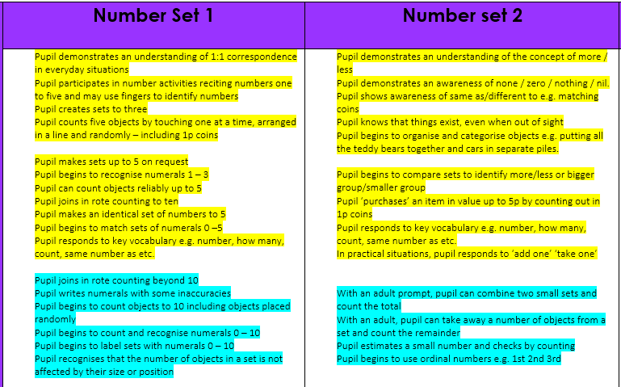

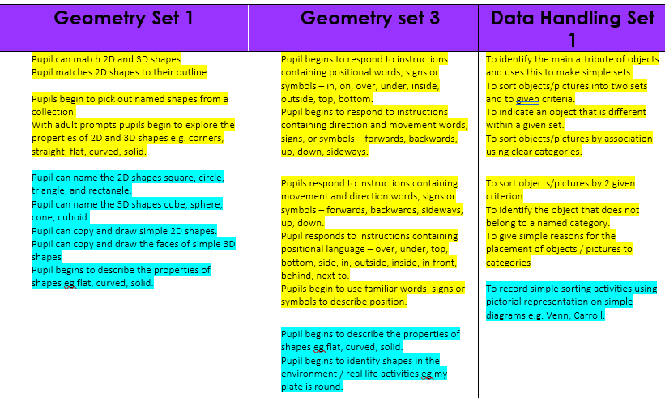

***In our learning environment, displays and provision we are trying to support and facilitate the following knowledge and skills; Turn taking, sharing, waiting/ patience, imaginative play, positive relationships***

***To support pupils to have a voice we will use…***

***Signs, symbols, picture cues, PECs, communication strips/books***

**Class:*****Holly***

**Pathway*: Semi-formal***

**Term***:* ***Autumn 2***

**Composite Half Termly End Point:**

**Yellow: Begin to understand that other people have needs and to respect these. Take part in activities involving two or three other learners.**

**Blue: Begin to recognise and name the needs and feelings of others Treat living things and their environment with care and concern.**

**PE**

**Strand: Gymnastics**

**DT**

**Strand: Materials**

**RE**

**MUSIC**

**Science**

**Strand: Materials**

**MATHS**

***To support pupils to develop independence we encourage…***

***Tidying up, choosing from a limited range, self-dressing***

***To support behaviours in our class you will see the following strategies:***

***Now and next sentence stems, 5 second count down, embedded routines and structure***

**Cognition & Learning**

**Social, Emotional & Mental Health**

**Communication & Interaction**

**Physical & Sensory**

**Developing Independence**

**RSE**

**MY WORLD**

**PSHE**

**Theme:**

**Cultural Celebrations**