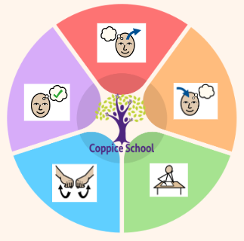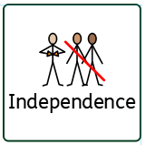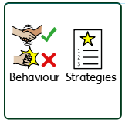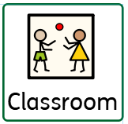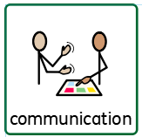

**Composite Half Termly End Point:**

**Red:** Indicate my like or dislike of a presented activity. Recognise my own possessions (e.g. coat, bag.)

**Yellow:** Make the choice to have or do something that makes me happy. Copy faces and expressions during Intensive Interaction.

**Blue:** Express my own emotions (e.g. sad, happy, cross, scared, worried.) Show awareness of my own feelings and a knowledge that my actions and words can hurt the feelings of others.

**Composite Half Termly End Point:**

**Red:** Begin to respond to the feelings of others, for example, mimicking their facial expression or sounds.

**Yellow:** Use single elements of communication, for example, words, gestures, signs or symbols, to express their feelings.

**Blue:** Recognise and name the needs and feelings of others. Understand how different people show love and compassion.

**Communication Half Termly End Point:**

**Red: Listen to sounds, join in with actions, respond at one word level, show understanding of objects, use single words, signs,symbols, communicate purposefully.**

**Yellow: Recognise and respond to sounds, show an interest in playing with sounds, select objects by name, understand 3 key words, communicate in different situations, communicate using 2 words, signs, symbols.**

**Blue: Enjoy familiar poems, verses, etc, identify words with specific sounds. name objects from verbal descriptions, understand humour, use and/because, retell a simple event.**

**Reading Half Termly End Point:**

**Red: Listen to books and show interest in pictures, respond to familiar rhymes, have favourite books.**

**Yellow:Discriminate between sounds, know letters convey meaning, matching pictures and symbols, choosing symbols, answer simple questions, repeat words/phrases from familiar stories.**

**Writing Half Termly End Point:**

**Red: Explore objects with hands, hold mark making tools, recognise familiar rhymes, scribble, make dots, travel with pecs cards.**

**Yellow: Follow a route with mark making tool, make marks resembling letters from name, make choices about mark making, listen to sounds at beginning of words, add descriptors to pecs.**

**Composite Half Termly End Point:**

**Red: Observe and show interest as people move around.**

**Yellow: Communicate about myself and people I know.**

**Blue: Add a caption or a label to a familiar picture or person.**

**Composite Half Termly End Point:**

**Red: Gazes at mirror image of self and recognises self. Imitates actions they have observed. Finds parts of body as a game.**

**Yellow: Points to body parts and begins to notice similarities.**

**Blue: Begin to look closely at our bodies. Begin to know the senses.**

**Composite Half Termly End Point:**

**Red:** Take a few turns in a game with support. Accept interaction with another person (e.g. give and receive an object.)

**Yellow:** Show an interest in other’s play and begin to join in. Tolerate being part of a small group.

**Blue:** Confidently interact with other children when playing. Initiate physical play.

**Composite Half Termly End Point:**

**Red:** Move to music. Stop and start when the music stops and starts. Play musical statues. Move rhythmically to music.

**Yellow:** Dance to music when the music starts. Initiate movements using simple rhythms. Use arm movements when dancing. Move freely and confidently.

**Blue:** Spring 2025 Move using simple rhythms Explore basic body actions in dance. Work in small groups and pairs.

**Composite Half Termly End Point:**

**Red: Explore and experiment with a range of food.**

**Yellow: Choose from fruit or veg and chop, grate, peel and blend.**

**Blue: Begin to be interested in textures and tastes. Handle equipment safely.**

**Composite Half Termly End Point:**

**Red: Make deliberate marks using a variety of tools.**

**Yellow: Imitate drawing circles and lines. Experimetn with a range of painting techniques.**

**Blue: Create simple representations of people. Look at, identify, describe similarities, differences, patterns and textures.**

**Maths Number Set 2**

**Red: To know 1, lots of, number names.**

**Yellow: To categorise objects, know more and less, nothing, same, different.**

**Blue: To combine two sets, count a remainder, use ordinal numbers, begin to estimate.**

**Geometry Set 3**

**Red: To find objects in their place or moved.**

**Yellow: To respond to positional language.**

**Blue: To describe properties of shape.**

**Books: The Invisible**

**Eleanor’s Eyebrows**

**Theme: Funny Faces**

**PE**

**Strand:**

**DT**

**Strand:**

**Class Focus:**

**ART**

**Strand:**

**Class Focus:**

**RE**

**History**

**Strand:**

**Class Focus:**

**Science**

**Strand:**

**Class Focus:**

**ENGLISH**

**Class Focus:**

**MATHS**

***To support pupils to develop independence we encourage…***

***To support pupils to have a voice we will use…***

***To support behaviours in our class you will see the following strategies:***

**Class:**

**Pathway:**

**Term***:*

***In our learning environment, displays and provision we are trying to support and facilitate the following knowledge and skills;***

**Cognition & Learning**

**Social, Emotional & Mental Health**

**Communication & Interaction**

**Physical & Sensory**

**Developing Independence**

**RSE**

**MY WORLD**

**PSHE**