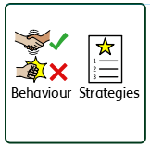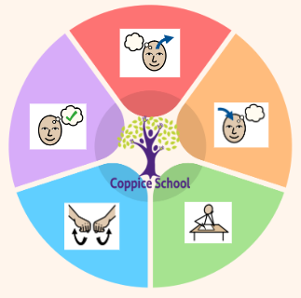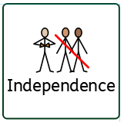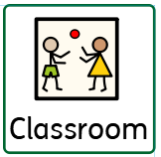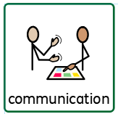

**Books:**

The Artist – By Ed Vere

The Lines on Nana’s Face -By Simona Ciraolo

George’s Marvellous Medicine- Roald Dahl

**Strand 2: Geometry/Time**

**Half Termly End Point:**

**Yellow:** With adult prompts pupils begin to explore the properties of 2D and 3D shapes e.g. corners, straight, flat, curved, solid.

**Blue:** Pupil counts the number of corners, sides and faces of everyday objects.

**Green:** Draw the hands on a clock face to represent the hour and half past the hour.

**Orange:** Name and order seasons of the year and identify festivals associated with them.

**Strand 1: Measure/Shape**

**Half Termly End Point:**

**Yellow:** Uses familiar words to describe the size of objects, i.e. big and small.

**Blue:** Begins to order objects by size, length, height using direct comparison

**Green:** Use everyday language to compare and sort 2D and 3D shapes.

**Orange:** Compare and sort common 2d and 3d shapes and everyday objects.

**MATHS**

**Strand 1: Measure/Shape**

**Strand 2: Geometry/Time**

**Composite Half Termly End Point:**

**Yellow:** Imitate drawing circles and lines. Experiment with a range of painting techniques i.e. splatter painting.

**Blue:** Create simple representations of people. Look at, identify and describe similarities, differences, patterns, textures and changes.

**Green:** Draw lines of varying thickness, use dots and lines to demonstrate pattern and texture

**Orange:** Use key vocabulary to demonstrate knowledge and understanding such as, portrait, self-portrait, pastels, drawing, line, size etc. Use different drawing media to produce different textures.

**Composite Half Termly End Point:**

**Yellow:** Demonstrate use and function of familiar foods.

**Blue:** Handles equipment and ingredients safely and with increasing control, e.g. pouring flour.

**Green:** Identify cooking equipment that can be unsafe.

**Orange:** Choose the correct equipment and use it safely.

**Composite Half Termly End Point:**

**Yellow:** Demonstrate an awareness of some basic concepts - big and small ball, big and small steps.

**Blue:** Demonstrate an awareness of how different surfaces affect movement

**Green:** Confidently perform with accuracy, the different skills correctly and safely

**Orange:** Demonstrate positive interaction and ability to work together to solve and perform a range of tasks.

**PE**

**Strand: Outdoor adventurous activities**

**Composite Half Termly End Point:**

**Yellow:** Tolerate being part of a small group.

**Blue:** Confidently interact with other children when playing.

**Green:** Understand that we shouldn’t share private and personal information with strangers.

**Orange:** Understand that people on the internet are not always who they say they are and may have unkind intentions.

**RSE**

**Strand: Relationship**

***To support pupils to develop independence we encourage…***

Self-help, personal hygiene, independence, dressing, eating and making own snacks and drinks.

**Composite Half Termly End Point:**

**Yellow:** Demonstrate a basic understanding of an action they do which is wrong or right e.g. helping to tidy up, breaking a toy

**Blue:** Name, request and take part in multiple mediation activities.

**Green:** Understand the effect meditation activities can have on emotions as a basic level.

**Orange:** Understand the effect meditation activities can have on emotions and health.

**Composite Half Termly End Point:**

**Yellow:** Take part in activities that link to do different careers.

**Blue: i**dentify activities I like that are representative of different career.

**Green:** Link job titles and careers and job I like.

**Orange:** Identify some careers that link to activities and jobs I enjoy doing.

**MY WORLD**

**Strand: Citizenship Career**

**& Economic Wellbeing**

**RE**

**Strand: Peace**

**Composite Half Termly End Point:**

**Yellow:** Explore objects using their senses.

**Blue:** Sequence a life cycle of a human with at least three pictures.

**Green:** Can talk about the changes over time from babies to adults, by looking at photographs.

**Orange:** Describe the basic needs for a human and the changes as they grow to an adult.

**Science**

**Strand: Human body**

**Composite Half Termly End Point:**

**Yellow:** Understand that some language about immediate past and future e.g. later

**Blue:** Follow a simple visual timetable of three images

**Green:** Show chronological understanding

**Orange:** Extract information from picture

**History**

**Strand: Changes**

**Communication Half Termly End Point:**

**Yellow:** Begin to communicate using 2 words, signs or symbols

**Blue:** Begin to ask more complex questions.

**Green:** Ask and answer questions for specific information.

**Orange:** Ask relevant questions linked to the topic of conversation.

**Reading Half Termly End Point:**

**Yellow:** Begin to show curiosity about content at a simple level e.g. may be able to answer basic two-word question ‘what’s this?’

**Blue:** Describe the story settings, characters and main event in simple terms.

**Green:** Describe the actions of a character and the events in the story.

**Orange:** Understand, recount and sequence events and information.

**Writing Half Termly End Point:**

**Yellow:** Make my own marks in or about a piece of work.

**Blue:** Retell a simple story.

**Green:** Write speech bubbles next to a picture.

**Orange:** Communicate a story from a story map.

***In our learning environment, displays and provision we are trying to support and facilitate the following knowledge and skills;***

*Independence, communication and engagement.*

***To support behaviours in our class you will see the following strategies:*** *Countdowns, positive reinforcement, individualised boards, embedded routines, communication books.*

**ENGLISH**

**Theme:**

**Funny faces and fabulous features.**

**DT**

**Strand: Cooking**

**ART**

**Strand: 2D**

***To support pupils to have a voice we will use…***

Makaton, symbols, visuals, AAC’s, communication books

**Class:** *Hazel*

**Pathway:** Woodlands

**Term***:* Spring 2.

**Cognition & Learning**

**Social, Emotional & Mental Health**

**Communication & Interaction**

**Physical & Sensory**

**Developing Independence**

**PSHE**