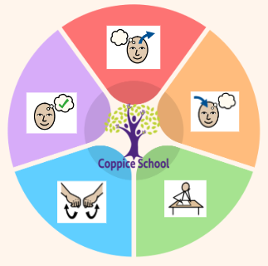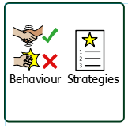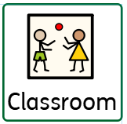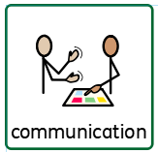

***In our learning environment, displays and provision we are trying to support and facilitate the following knowledge and skills;*** *Independence, appropriate interactions, solving problems and developing tolerance and patience.*

***To support behaviours in our class you will see the following strategies:*** *Clear routines, firm expectations, expected role modelling, time out.*

**HEALTH & WELL-BEING (PSHE)**

***To support pupils to have a voice we will use…*** *ensure that we are listening carefully when it is other peoples turn to speak, encourage students to have the confidence to share their thoughts/ideas.*

**Class:** The Bridge (J7)

**Pathway:** Formal

**Term**: Autumn 2 2024

**Cognition & Learning**

**Social, Emotional & Mental Health**

**Communication & Interaction**

**Physical & Sensory**

**Developing Independence**

**Theme:**

**Cultural Celebrations**

**Communication Half Termly End Point:**

**Green:** I can give descriptions and explanations. **Orange:** I can usually communicate in grammatically correct sentences.  **Turquoise:** I canbegin to try new vocabulary and phrases that has been heard or read from stories/texts.

**Reading Half Termly End Point:**

**Green:** I can express an opinion about a story/character.

**Orange:** I canexpress opinions and make predictions.  **Turquoise:** I canexplain opinions about what they have read.

**Writing Half Termly End Point:**

**Green:** I canwrite labels for others to read. **Orange:** I can begin to plan my writing.  **Turquoise:** I canshow an awareness of writing for different audiences.

**Strand 1: Measure - Weight (Week 7/8)**

**Half Termly End Point:**

**Green:** I can take part in practical activities that involve measuring using standard scales with support **Orange:** I can compare weights and record results using < > = **Turquoise:** I can measure and compare mass (kg/g)

**Strand 2: Number – Place Value (Week 9/10)**

**Half Termly End Point:**

**Green:** I cancount to and across 100, forwards and backwards, beginning with 0 or 1, or from any given number. **Orange:** I can use coins to make a total shopping bills. **Turquoise:** I know the value of each digit in a decimal number.

**Strand 3: Data Handling (Week 11/12)**

**Half Termly End Point:**

**Green**: I can sort and classify objects using a single criterion **Orange**: I can make numerical comparisons from bar charts **Turquoise**: I caninterpret information, to make comparisons and record changes, from different formats including bar charts and simple line graphs.

**Books:** A Christmas Carol (Abridged) - Charles Dickens; Wonder – Palacio R.J

**FUNCTIONAL ENGLISH**

**Strand:** Communication, reading and writing

**Class Focus:** A Christmas Carol

**FUNCTIONAL MATHS**

**Strand**: Weight, Place Value, Data Handling **Class Focus:** Measuring, money, Interpreting charts

**Composite Half Termly End Point:**

**Green**: I can express how a piece of music makes me feel.

**Orange**: I can listen to and engage with various genres of music.

**Turquoise**: I can describe how the music impacted my emotions and explain why

**MUSIC**

**Strand**: Cultural Sounds

**Class Focus:** Expressing emotion through music

**Independent Living**

**SCIENCE**

**Strand**: Materials **Class Focus:** Exploring materials when following a recipe to make an agreed product

**Enterprise & Employability – DT Strand**: Textiles

**Class** **Focus**: Creating items to sell

**Composite Half Termly End Point:**

**Green:** Manipulate materials in simple ways to create the desired effect, e.g. cut, score and shape. **Orange:** Demonstrate how to cut, shape, score and join materials with some accuracy to make a simple product. **Turquoise:** I can learn to use a variety of tools and equipment safely, correctly and with precision.

**Composite Half Termly End Point:**

**Green**: I can compare objects based on their features.

**Orange**: I can compare objects and group them based on their properties.

**Turquoise**: I can make basic predictions about the outcomes of an experiment

**Skills Builder**

**RE**

**Strand**: Kindness **Class Focus**: Undestanding me and those around me

**GEOGRAPHY**

**Strand**: Maps, travel & location **Class Focus**: Cultural places of interest

**Composite Half Termly End Point:**

**Green:** I can be aware of my own influence on events and other people

**Orange:** I candiscover some similarities and differences between people in my school community

**Turquoise:** I can be sensitive to the needs and feelings of others and show respect for themselves and others.

**PE Strand:** Fitness**Class Focus:** How does exercise help the body?

**RSE** **Strand**: Relationships and Families **Class Focus**: Types of family – qualities that are healthy in a family

**Composite Half Termly End Point:**

**Green:** I can develop my understanding of how exercise can make me strong and healthy.  **Orange:** I can explore exercises to develop strength. **Turquoise:** I can understand how strength helps us in everyday life.

**Composite Half Termly End Point:**

**Green**: I can identify a country and a cultural celebration that they take part in.

**Orange**: I can locate a country on a map/globe, recognising the cultural celebration that they take part in.

**Turquoise**: I can compare the locations of different countries on a map/globe, recognising the celebrations that they take part in

**MY WORLD Strand**: Citizenship  **Class Focus**: Healthy relationships – treating each other with respect

**Composite Half Termly End Point:**

**Green:** I can identify and explain similarities and differences between myself and others.

**Orange:** I can identify how I can help people around me.

**Turquoise:** I can know that we should treat all people in our community with respect.

**Composite Half Termly End Point:**

**Green:** I can understand that families are made up of a special group of people and this changes over time.

**Orange:** I can recognise different types of family, including those that may be different to my own.

**Turquoise:** I can recognise thatother shared characteristics of healthy life include commitment, care, spending time together and being there for each other in times of difficulty.

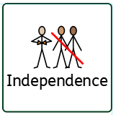

**To support pupils to develop independence we encourage;** *children to collect their own resources, follow tasks with minimal guidance, look after themselves and manage disagreements between themselves.*