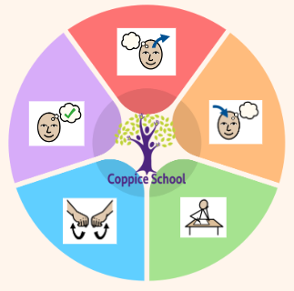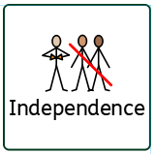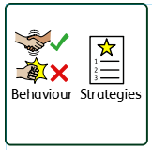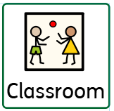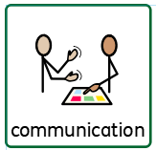

**MY WORLD**

**Strand: Citizenship Career**

**& Economic Wellbeing**

**Composite Half Termly End Point:**

**Yellow:** Take part in activities that link to do different careers. Respond to adult play linked to jobs/careers. Use money in play based games such as shopkeeper /customer

**Blue:** Identify activities I like that are representative of different career. Understand that I need to exchange money for items in a shop.

**Composite Half Termly End Point:**

**Yellow:** Demonstrate a basic understanding of an action they do which is wrong or right e.g. helping to tidy up, breaking a toy.

**Blue:** Demonstrate a basic understanding of what is right and wrong in familiar situations, evaluating own actions and begin to understand consequences

**Composite Half Termly End Point:**

**Yellow:** Respond to up and down by body movement. Demonstrate an awareness of some basic concepts - big and small ball, big and small steps.

Collect familiar pieces of equipment.

**Blue:**Climb up and down equipment with control. Climb a ladder with control. Jump to a height of 20cm. Jump over a hurdle. Move around obstacles when moving at speed.

**Composite Half Termly End Point:**

**Yellow:** Show an interest in other’s play and begin to join in. Tolerate being part of a small group.

**Blue:** Confidently interact with other children when playing.

Initiate physical play.

**Communication Half Termly End Point:**

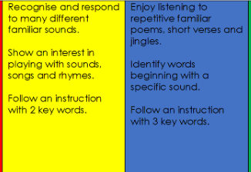

**Reading Half Termly End Point:**

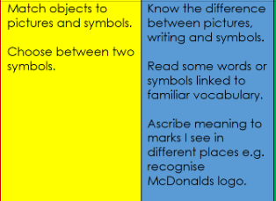

**Writing Half Termly End Point:**

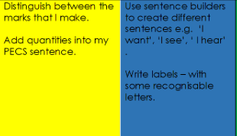

**Composite Half Termly End Point:**

**Yellow:** Demonstrate use and function of familiar foods.

**Blue:** Begin to be interested in and describe the textures and tastes of foods.

**Composite Half Termly End Point:**

**Yellow**: Understand that some language about immediate past and future e.g. later

**Blue:** Follow a simple visual timetable of three images

**Composite Half Termly End Point:**

**Yellow:** Explore colour and mixing colours.

**Blue:** Create simple representations of people.

**RE**

**Strand: Peace**

**RSE**

**Strand: Relationship**

**Science**

**Strand: Human Body**

**Books**:

The Artist – By Ed Vere

The Lines on Nana’s Face -By Simona Ciraolo

George’s Marvellous Medicine- Roald Dahl

**Class:** *Holly*

**Pathway: Semi-Formal**

**Term***: Spring 2*

**PE**

**Strand: Outdoor Adventure Activities**

**DT**

**Strand: Cooking**

**ART**

**Strand: 2D**

**Composite Half Termly End Point:**

**Yellow: Points to more complex body parts. Begin to notice similarities and differences.**

**Blue: Sequence a life cycle of a human with at least three pictures.**

**History**

**Strand: Changes**

**ENGLISH**

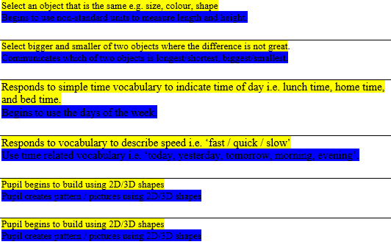

**MATHS**

***To support pupils to develop independence we encourage…***

***To support pupils to have a voice we will use…***

***To support behaviours in our class you will see the following strategies:***

***In our learning environment, displays and provision we are trying to support and facilitate the following knowledge and skills;***

**Cognition & Learning**

**Social, Emotional & Mental Health**

**Communication & Interaction**

**Physical & Sensory**

**Developing Independence**

**PSHE**

**Theme:**

**My Colourful World**