Curriculum & Assessment Policy
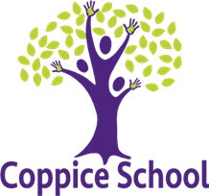

Coppice School Specialist Setting
Updated October 2023

Our Vision
‘No Limits’ - An ambitious offer to all pupils which develops and nurtures…
Life-Long Learning & Knowledge
Interests & Opportunities
Mental health and positive wellbeing
Imaginative and Meaningful experiences
Togetherness & Inclusivity

Our Values

We are kind, We try our best, We prepare for the future

Curriculum Intent Headline
To provide all our pupils with the knowledge and skills they need for life after Coppice.

Curriculum Intent Statement
Intent: the extent to which your curriculum (through its design, structure and sequence) sets out the knowledge and skills that pupils will gain at each stage.
We believe in a broad and balanced ‘No Limits’ curriculum that develops and nurtures Life-long learning, builds Interests, supports Mental health & wellbeing, is Imaginative and provides meaningful opportunities and promotes Togetherness in the school and wider community. It is Happy Centred, driven by Confidence, Positive Relationships, Support, Coping Skills and Achievement and Success.
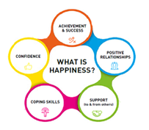
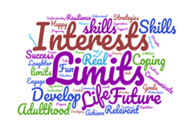

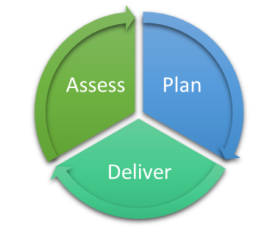

Curriculum Implementation at Coppice
Implementation: the way in which your curriculum is taught and assessed, in order to support pupils to build their knowledge and to apply that knowledge as skills.
- EHCP’s are at the core of our learning experiences and are integrated through all aspects of the school day.
- Detailed progression maps identifying knowledge and skills have been developed for each subject, to support this a rigorous CPD programme is provided to ensure all staff have expert knowledge in all the subjects they teach (pedagogical approaches – CPD).
- Daily formative assessments, half termly summative assessments (Evidence for Learning) and Pupil Outcome Review Meetings are completed to ensure that gaps in learning are identified.
- Appropriate Strategies to support pupils with understanding, such as: Makaton, symbols and reduced language are consistently used when communicating with pupils.
- Therapies to support engagement and behaviours for learning, and used additionally to support pupils throughout the day.
- ASD strategies are an integral part of our curriculum and school life to ensure all pupils remain regulated and ready for learning.
- Behaviour for learning is also essential and staff use strategies for each individual learner to support them to be in a sensory and emotionally regulated state ready to learn.
- Observational assessments and Blank Level questioning are used within all lessons to check pupils understanding. Scaffolding, adaptive teaching and a tiered support system are used to support all pupils and to address any misunderstandings.
- Repetition, cross-contextualisation and ‘tinkering’ are three key components that teachers use to support pupils to transfer knowledge from working memory to long term memory.
- Our curriculum is supported by the statutory requirements of the Early Years Framework and the National Curriculum in England, whilst ensuring personalised, differentiated learning for every child.
- We have two consecutive Happy Centred Schools lesson each week in which we teach PSHE, British Values, SMSC, and RE.
- Content and activities are presented through a thematic approach that is personalised to meet the needs (EHCP’s), interests and developmental ability. Each term a new theme is introduced, each theme has a Biophilic and sustainability link and although themes aren’t repeated they have been carefully planned to ensure pupils can build upon previous knowledge, skills and experiences.
- Whole school termly, thematic approach allows for collaborative projects across multiple classes. A termly parent/carer event is organised by staff and pupils to introduce the theme and provides parents with the knowledge and skills to support pupils with home learning.
- Children requiring additional support to meet their needs have personalised interventions, for example, sensory diet interventions. Occupational Therapy, Speech and Language and Physiotherapy programmes are delivered across the curriculum.
- PAL, Outdoor learning and our Biophilic environments help to support the mental health and wellbeing of our pupils and aid engagement in learning.

Impact
Impact: The outcomes pupils achieve as a result of the education they receive – they should know more and be able to do more than when they started.
- Children are equipped with useful, practical and transferable key skills, preparing them for their next steps.
- Essential skills for life are developed so that children have control over their lives and can make their own decisions.
- Children are happy at school and feel safe, nurtured and cared for.
- Children’s success and achievements are celebrated within each class on a bespoke level to ensure it is meaningful to each pupil.
- Children and staff use our school vision to reflect upon their own achievements and development.
- We believe that quality first teaching, leads to an enjoyment of learning and happy and rewarding lives.
- Visitors and prospective parents consistently comment on the lovely atmosphere, ethos and environment the school team has created.
- Overall curriculum impact is measured pupil by pupil, based on their own individual starting points (ipsative progress) and their outcomes as a result of the curriculum.

Curriculum Aims
- To recognise that every child is an individual with individual needs and abilities.
- To ensure that every pupil has access to a curriculum that embraces the development of cognitive, social, moral, spiritual and cultural learning.
- To ensure that pedagogy and assessment enable and reflect the progress made by all individuals.
- To provide an enabling environment in which each individual can develop and make progress.
- To ensure the environment meets sensory and physical needs of the pupils.
- To provide a curriculum which meets the needs of all of our pupils through our No LIMITs ethos.
- To provide a knowledge rich curriculum, building on the development of knowledge and skills for life for all learners.
- To reflect the importance of all 4 areas of need in the SEND code of practice, through our EHCP’s, which underpins our curriculum.
- Ensuring opportunities for progression run throughout the curriculum through the use of our bespoke progression maps.
- Develop pupils’ independent learning skills and resilience in order to best equip them for their life after school.
- To ensure that each pupil is able to achieve their fullest potential through planning, recording, assessing and monitoring in a systematic way.

Legislation & Guidance
This policy reflects the requirements for academies to provide a broad and balanced curriculum as per the Academy Act 2010. It also reflects the recommendations for learners working below the standard of the national curriculum tests in the Rochford Review.
Our bespoke curriculum takes key and cross-linking knowledge and skills from the following documentation: National Curriculum Programs of Study, End of Key stage Expectations, Early Years Foundation Stage (EYFS) Statutory Framework 2021, AQA Unit Awards, Development Matter – Tapestry SEND 2012, P Levels.

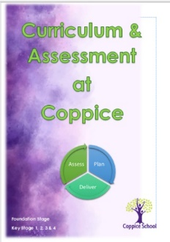
This policy is also in a handbook guide to support staff to
ensure all staff understand the expectations for planning
and assessment.

Teaching & Learning Standards
Teacher Standards 2. Promote good progress and outcomes by pupils

- Be accountable for pupils’ attainment, progress and outcomes.
- Be aware of pupils’ capabilities and their prior knowledge, and plan teaching to build on these.
- Guide pupils to reflect on the progress they have made and their emerging needs.
- Demonstrate knowledge and understanding of how pupils learn and how this impacts on teaching.
- Encourage pupils to take a responsible and conscientious attitude to their own work and study.

Teacher Standards 3 Demonstrate good subject and curriculum knowledge

- Have a secure knowledge of the relevant subject(s) and curriculum areas, foster and maintain pupils’ interest in the subject, and address misunderstandings.
- Demonstrate a critical understanding of developments in the subject and curriculum areas, and promote the value of scholarship.
- Demonstrate an understanding of and take responsibility for promoting high standards of literacy, articulacy and the correct use of standard English, whatever the teacher’s specialist subject.
- If teaching early reading, demonstrate a clear understanding of systematic synthetic phonics
- If teaching early mathematics, demonstrate a clear understanding of appropriate teaching strategies.

Teacher Standards 4 Plan and teach well-structured lessons

- Impart knowledge and develop understanding through effective use of lesson time.
- Promote a love of learning and pupil’s intellectual curiosity.
- Set homework and plan other out-of-class activities to consolidate and extend the knowledge and understanding pupils have acquired.
- Reflect systematically on the effectiveness of lessons and approaches to teaching.
- Contribute to the design and provision of an engaging curriculum within the relevant subject area(s).

Teacher Standard 6. Make accurate and productive use of assessment
- Know and understand how to assess the relevant subject and curriculum areas, including statutory assessment requirements.
- Make use of formative and summative assessment to secure pupils’ progress.
- Use relevant data to monitor progress, set targets, and plan subsequent lessons.
- Give pupils regular feedback, both orally and through accurate marking, and encourage pupils to respond to the feedback.
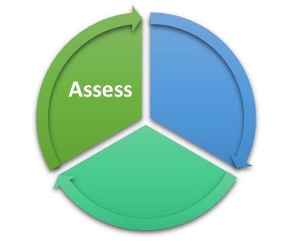

- Assessment
1.1 Assessment Baseline
Baseline assessments take place on Evidence for Learning 6 weeks after the start of the beginning of Autumn Term. Using the summative recording option on Evidence for learning staff can record a baseline assessment of E – emerging, D – developing, S- Secure or G- Generalised against their EHCP targets and Progression maps.

Evidence towards this is also gathered during transition meetings with the previous and new class teacher and team. During transition meetings previous class teachers and teams meet together with the new class teams to share information around each pupil in the class, key points for discussion should include;

• EHCP Targets , progress towards them and next steps.
• Communication strategies, PECS phase, Symbol stage and next steps.
• Provision band, Pathway and next steps.
• Level of independence and personal care requirements.
• Sensory and behavioural needs and strategies.
• Health needs.
• Likes & Dislikes

A regular cycle of Assess, Plan and Deliver should take place daily to ensure
the best progress for the pupils at Coppice.

  - Daily Formative Assessments

Outcome Feedback—Staff are encouraged to provide feedback to the class lead on the progress and outcomes a pupil has made during a planned lesson. This can be written annotations, agreed class codes or verbal feedback, through professional discussions.

Observational Evidence – Photographs, videos or written observations can be recorded on Evidence for Learning and linked to specific curriculum progression maps/frameworks or EHCP targets. Observational assessments can also be added here to form engagement profiles. Work produced as a result of a lesson/session can be added to work books and contribute towards evidence.

Reading—1:1 reading should take place every day and staff should record this in reading records. Pupils accessing Phase 2-6 and beyond should have a phonics linked reading book, logged in and out of the library which is then held on the Library system.

Communication— Through daily use of PECS and staff being aware of the Phases within PECS pupils should be appropriately challenged multiple times on a daily basis, staff should know the next steps for the pupil in their class and discussed as a class team. Communicative levels are recorded on each pupils’ universal passport and information passed on through transition meetings for the following year.

  - Weekly Formative Assessments

Assessment for Learning - Use of evidence and feedback gathered during the week should be checked and reviewed to inform next steps and planning for the week ahead.

Evidence Review – check for range of evidence for pupils in class across EHCP targets and progression maps.

Pupil Review – During whole class team protected time, discussions around the pupils, outcomes they have achieved, changes or behavioural issues, barriers to learning and steps to support these should be shared and addressed during the coming week.
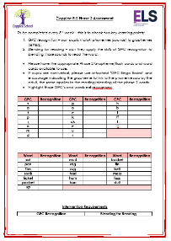
  - Half Termly Summative Assessments

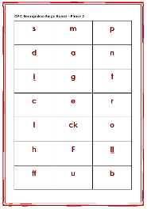
Phonics Assessments – For pupils who are being taught ELS adapted Phonics phases 2,3,4 and 5, phonics assessments should take place at the beginning of the 5th week of every half term. Gaps in knowledge are identified and the remainder of the week should be used to address the gaps in knowledge.

Class Team Reflection – Prior to the next term commencing, meet together as a team to discuss each pupil, their progress towards their EHCP Targets and where they currently are on the progression maps (what colour band) are they secure? Possible next steps. Plan for the next term, linking in our No LIMITs Vision.
Half Termly Summative – Recorded on Evidence for Learning against the Foundation Subjects being taught within that theme and against English & Maths Progression Maps. In addition progress towards EHCP targets is also recorded as a summative assessment.

  - Termly Summative Assessments

Pupil Outcome Reviews – Teachers meet with SLT 3 times per year to have an in depth professional discussion regarding the ipsative progress for pupils in their class. This provides the impact of our curriculum. During this discussion meeting staff provide evidence from a range of sources and professional knowledge of the pupil to share their achievements and ipsative progress, from their own starting points, their barriers to learning and the strategies; section F which are put in place to support and develop the pupil as an individual.
Nexus Pupil Progress – Information regarding ipsative progress for each pupil is shared with Nexus Mat each term.

Class Team Reflection – In Preparation for the next term using the Theme Curriculum Document - Discuss and plan as a class team how that will be personalised to your class. -See Planning. Ensure Universal Passports and one-page profiles are up to date.

  - Yearly Summative Assessments

Annual Review and EHCP update – Annual Review documents and EHCP up dated document should be fully completed 3 weeks prior to the Annual Review meeting with parents and other professionals. A phone call with parents or carers should take place as these documents are being prepared to ensure their views are heard.

- Annual Review reports progress against the Long Term & Medium-Term targets.
- EHCP document reflects up to date information regarding strengths and areas of support. New targets are also set for the coming year and Section F should be amended to reflect current practise in class.
- Ensure Parent/Carer views are incorporated—forms sent out to parents to complete (see policy)

Reports to Parents – Parents are entitled to an end of year report to share the progress and achievements their pupil has made during the year along with next steps which align to their EHCP Targets. This is followed by a discussion through a parents’ meeting if required. During Spring 2024 Evidence for Learning Parent Portal will be trialled so Parents and families have access to their child’s observational assessment information, where they can equally contribute to keep them up to date with progress and achievements made.

Transition Meetings - During transition meetings previous class teachers and teams meet together with the new class teams to share information around each pupil in the class, key points for discussion should include;

- EHCP Targets, progress towards them and next steps.
- Communication style, PECS phase, Symbol stage and next steps.
- Provision band, Pathway and next steps.
- Level of independence and personal care requirements.
- Sensory and behavioural needs and strategies.
- Health needs.
- Likes & Dislikes

Transition forms to be completed.

1.7 Assessment Refinements
Used summatively against EHCP medium term targets and colour provision bands within progression maps.
In order to mark a pupil against a colour provision band, pupils can be; Emerging, Developing, Secure or Generalised within that band and the previous and follow bands, meaning they can work across several provision bands. In order to be consistent when we mark these as achieved we need to apply the following before the statement is highlighted/marked as achieved.
- Emerging – the knowledge/skill is new and has only been seen once or twice, it may have been fleeting, accidental or supported by an adult.
- Developing – The knowledge/skill is becoming embedded and the pupil is showing more often that they are able to do/apply/understand the skill, but it is not consistent and adult support may still be needed.
- Secure – Pupils are confident in the knowledge/skill and show they can do/know this consistently.
- Generalised – Pupils have cross contextualised the skill and can apply their knowledge in a range of ways independently.
Spikey Profiles.
Pupils can be secure in one band and emerging in another, in choosing one or another, the pupil is thought about holistically, their developmental stage, consistency and transferability of skills.
Equally pupils may be in a higher provision band in one subject area and lower in another.
It is important to remember there is overlapping between the bands, particularly Pink to Green, based on the Development Matters Statements used to create the curriculum.

2.Assessment Systems
2.1 Evidence for Learning
Evidence for Learning was introduced in June 2023. Staff use this to collect observational assessments, through videos or photos with a written summary of learning or achievement which has taken place. This evidence can then be linked to specific EHCP targets or to curriculum progression maps to contribute towards the learning journey for that pupil. This is how the system is used formatively. Staff also use this to record summative judgements against the pupils’ medium-term targets and against colour provision bands within the subject progression maps.

2.2 Pupil Outcome Review Meetings
During every term staff gather information, assessments and data for all the pupils in their class in preparation for a pupil progress meeting with a member of SLT. During this meeting staff will share evidence and professional knowledge to help to build a holistic view of the day to day running, management and workings of a class. SLT will choose one pupil to discuss in depth and at length, however, there should also be an opportunity to discuss any pupil who has been assessed as making Red or little progress, in order to better support the needs of the pupil, enabling them to make better progress for them.
Prior to the meeting it is expected that class teachers triangulate evidence for each pupil and RAG rate their progress against area of need. Observational assessments and colour provision band information along with their own knowledge of any supporting information to explain the progress.
During the meeting class teachers will share, through professional discussions how they plan, assess and meet the needs of the pupils in their class. Staff are encouraged to share examples of good practise, achievements and areas they wish to receive further support with. SLT will offer professional challenge and support.
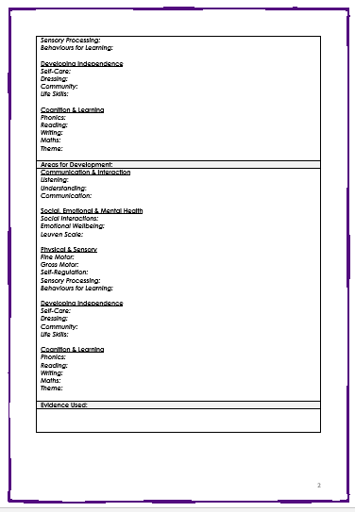
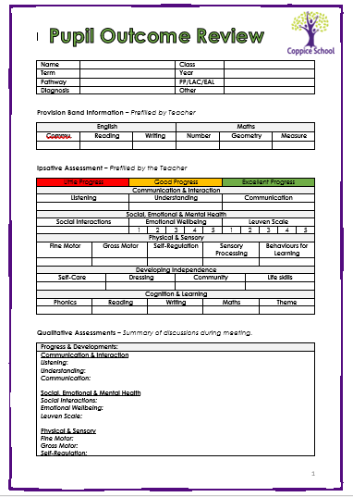
After the meeting a member of SLT will email the completed and agreed discussion form.

As a result of the pupil outcome review, where one selected pupil is discussed in depth and at length, judgements will be accepted for all pupils in the class, if the staff member shows a clear and in depth understanding of the pupil and is able to professionally discuss against all aspects of the review meeting, and provide sufficient evidence then all other judgements will be accepted. If, however, a staff member is not able to accurately articulate a sound understanding of the chosen pupil during the review and insufficient evidence is provided then other judgements will not be accepted and the staff member will be asked to quality assure all other pupils in class and return for a follow up meeting.

2.3 Progress

Progress is measured ipsatively for each pupil as an individual, from their own starting point, taking into account a range of factors which are specific to them e.g. barriers, strengths and engagement.
RAG ratings for Pupil Outcome Reviews are as follows;

Red – Little Progress
Amber – Good Progress
Green – Excellent Progress

The RAG ratings for each pupil is also highly individualised and all factors regarding their diagnosis, barriers, needs and achievements are taken into account. For example; for pupils with degenerative conditions, maintenance of skills should be seen as good progress for them. Where as for other pupils this may be seen as little or no progress. It is important to remember that we do not compare one pupil and their achievements and progress against another.

Red or little progress is defined as; a pupil who is disengaged from learning, frequently dysregulated, has plateaued or even regressed against progression maps or EHCP targets. In this instance there needs to be a support plan put in place in order to meet the needs of the pupil to enable them to progress.

Amber or Good Progress is defined as; a pupil who has gained in the acquisition of knowledge and skills through specific colour provision band planned for learning opportunities, EHCP targets and other areas where the pupil has been deemed to make good progress such as behaviours for learning, limited times of dysregulation and good engagement in learning time.

Green or Excellent Progress is defined as; a pupil who exceeds in planned and unplanned for learning times, who is consistently engaged in learning or has made progress far beyond what has been expected of them in given time frame.

  - Curriculum Progression Maps & Colour Provision Bands

Coppice Curriculum Progression maps provide the knowledge and skills our pupils need across all subject areas are sequential, based on developmental stages of learning, which builds on prior knowledge and skills. In order to accurately plan and pitch lessons staff need to be aware of the colour provision band each pupil is working within across all subject areas. These are also organised along specific pathways.
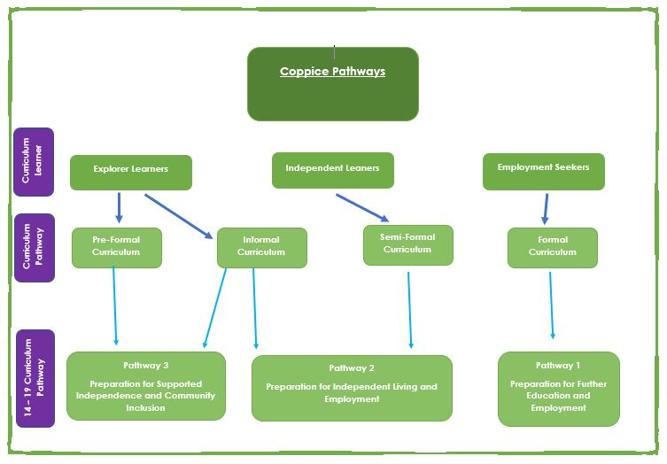

3.1 Pathways
Dependent upon the pathway and the colour provision band each pupil is working within planning, pedagogy and assessments will be reflective of their stage in development.
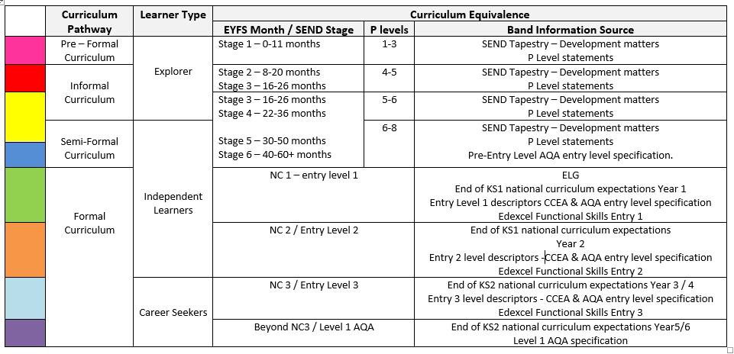

These pathways support the knowledge and skills a pupil needs based on their own individual starting points for their further education beyond Coppice. The pathways are then broken down into more specific colour provision bands, which contain the developmental knowledge and skills within that band.
3.2 Pathways
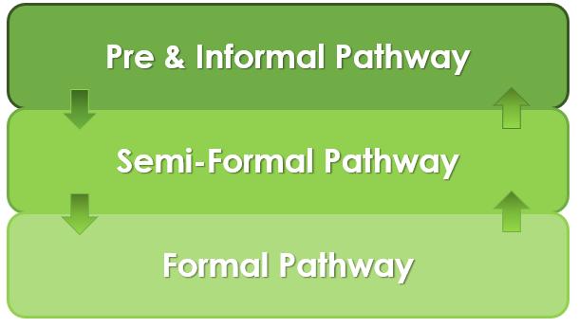

Pre & Informal Pathway – Pink, Red & Yellow Provision Band

Our pink, red and yellow colour provision bands make up our Pre-Formal and Informal pathway.
The Pre-Formal and Informal Curriculum and engagement scales give children time and opportunities to experience the world around them. Activities within each area of learning are planned carefully using a multi-sensory approach so that children are able to engage and begin their learning journey. The focus of the areas of learning are to teach the children the skills they need to be safe, happy, healthy, and able to experience as much of the world as possible around them.
Structure and repetition, facilitated by skilled staff form the foundations of our day. We strive to ensure a personalised approach, where advice from therapists and healthcare plans are integrated into daily planning, which are informed by the EHCP plan.
Our children are learning to learn, and the smallest of steps are celebrated.

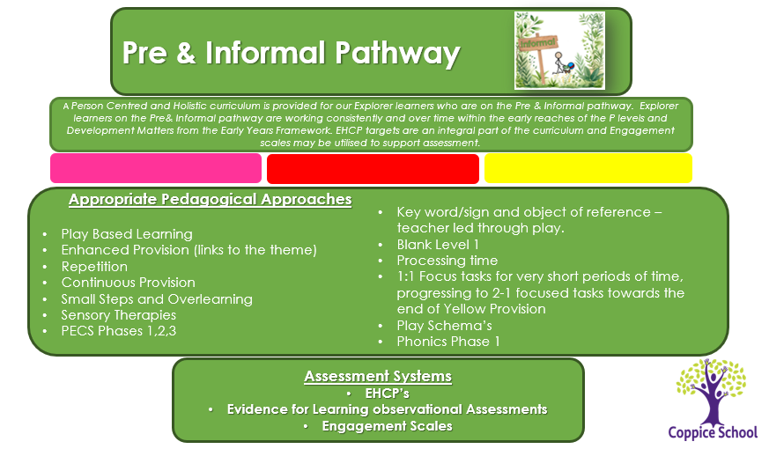

Semi-Formal – Yellow & Blue Provision Band
Children within the semi-formal phase are still in the early stages of their learning and development.
Developing the use of functional expressive communication, through a holistic approach is central to learning. Children are encouraged to engage and form secure relationships with adults to support their engagement in adult-led activities. Independence is always encouraged. Behaviour for learning is also essential and staff use consistent strategies for each individual learner to support them to be in a sensory and emotionally regulated state ready to learn.
The focus of English in the semi-formal curriculum is to develop early reading and writing skills based on phonics and the construction of simple sentences. Environments will be developed to be reading and writing rich encouraging pupils to develop independent skills and access exploratory learning in order to see themselves as readers and writers.
Mathematics teaching will embody the principles of active and exploratory learning based on concrete materials. Number rhymes and stories will form the basis of early mathematical teaching and will allow pupils to develop number awareness
Teaching and learning are strengthened because staff know children very well and they know what motivates individual learners. Staff take the children motivators into account to promote learner engagement.
Each class utilises and develops learner skills to encourage exploration to develop growing independence.

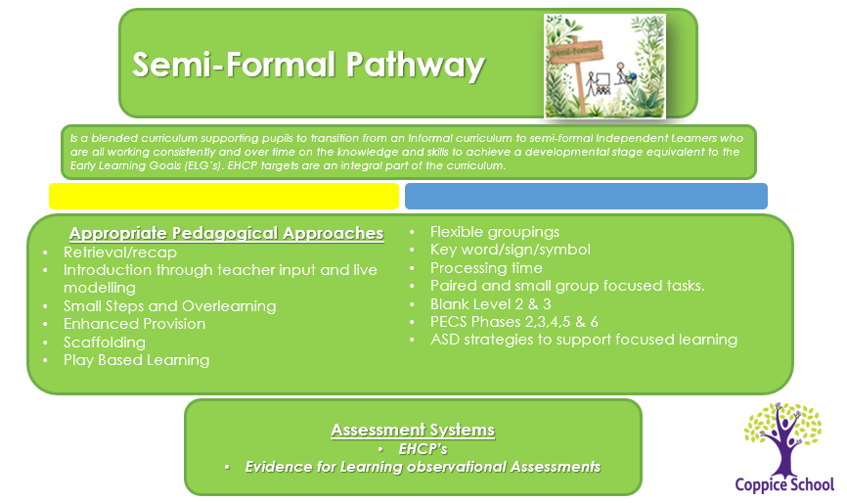

Formal Curriculum Pathway – Green, Orange, Turquoise & Purple Provision Bands
Although there are elements of a mainstream model, consideration is given to an adapted curriculum which reflects the whole child’s needs.
Children access work at their individual level, and where appropriate, access inclusive links in mainstream schools; ensuring they are progressing within the national curriculum framework and continuing to make good linear progress.

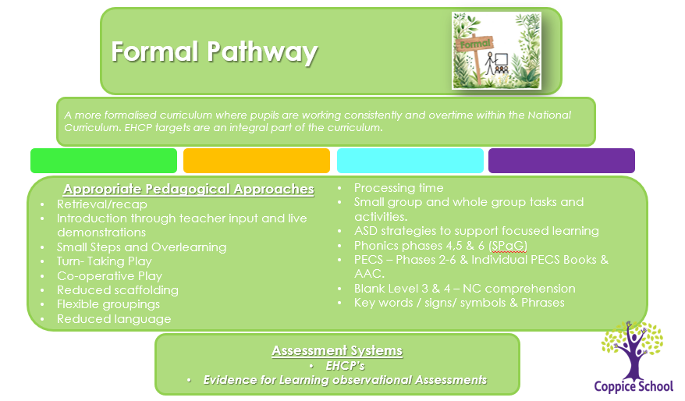

3.3 Marking Policy in Practise
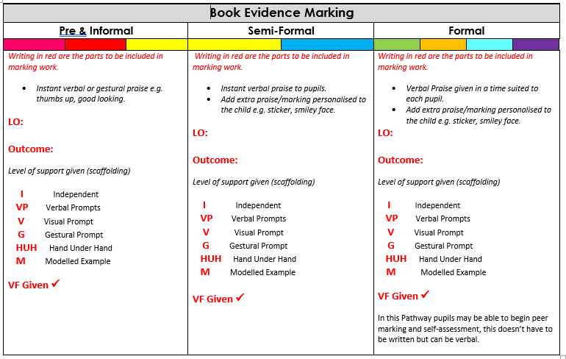
All work evidence placed in books should be marked for the pupil according to the learner pathway on which they are currently working within. Based on the Marking policy the staff member completing the work with the pupil should indicate the type of support or prompting they have received. The lesson objective should be evident and written at the top of the page and the pupil outcome as a result of the session. We are aware this may be different to the planned objective, however, this supports our pupil centred curriculum approach to learning.

4. Progression Maps
Progression maps are our bespoke curriculum and have been created for all subject areas. They are based on developmental milestones, skills and knowledge which increase in complexity, moving from pink through to purple provision. The sources for the statements within each colour provision band have been taken from a variety of statutory sources such as Development Matters 2012 (SEND Tapestry adjustments) P levels, National Curriculum end of year expectations, AQA unit awards for Pre-entry, Entry 1, Entry 2, Entry 3 and Level 1 requirements. The Progression maps and provision bands ensure key skills are accounted for and built upon in the following bands.
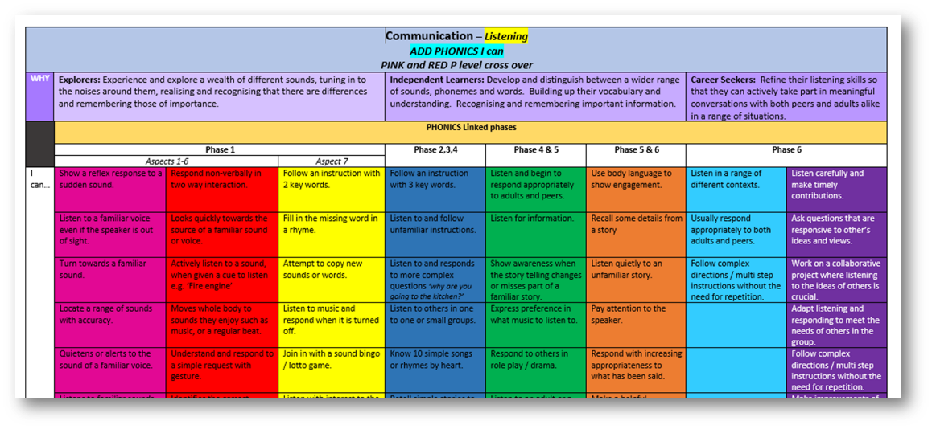

4.1 Progression Map quality Assurance
During the creation of the curriculum progression maps, staff had taken into account the current statutory curriculum documents (P Levels, Development Matters 2021 – SEND Tapestry adaptations, National Curriculum end of year expectations KS1 & 2, Edexcel functional skills pre-entry, entry level and level 1 specification, AQA pre-entry, entry level and level 1 specification). To ensure consistency in expectation across the progression maps an aligned grid of curriculum sources has been created to document where the statutory information has come from aligned to the colour progression maps.
The maps were quality assured against the original documentation and will continue to be adapted through an ongoing process to be checked against the latest statutory changes, government and research driven guidance.
4.2 Moderation
As a part of the schools’ program of CPD, teaching staff take part in a regular cycle of moderation staff meetings. The intent of these meetings is to ensure consistency in understanding of the colour provision bands within the progression maps. Consistency in expectations of these bands helps to ensure pupils are assessed and planned for accurately and through transition meetings consistency between classes is maintained.

5. Class Groupings & Organisation
5.1 Class Groups
Pupils from September 2023 will be grouped according to their pathway. This is determined by the pupils’ levels of attainment in English and Maths aligned to the provision bands.
5.2 Class Timetables
All class timetables include English (3 per week), Maths (3 per week) and Theme sessions, including weekly physical development sessions, life skills and therapy sessions. Each class throughout school has daily phonics sessions included and as pupils move through to upper school they also receive a more bespoke curriculum to work towards accreditation.
* this will be reviewed in line with the formation of new pathway leads, two classes are currently trialling play based timetables to support the Pre & Informal Pathways.
6. Pupil Documentation
* All pupil information can be found on the electronic ‘Shared Area’ under ‘Pupil Information’.

6.1 Engagement Profiles
The engagement model is the assessment (replacing P scales 1 to 4) for pupils working below the standard of national curriculum assessments and not engaged in subject-specific study. Teachers must use the engagement model to assess pupils working below the standard of the national curriculum assessments and not engaged in subject-specific study at key stage 1 and key stage 2. – DfE 2022.
The engagement model has 5 areas of engagement:
- exploration
- realisation
- anticipation
- persistence
- initiation
These areas allow teachers to assess pupils’ engagement in developing new skills, knowledge and concepts in the school’s curriculum by demonstrating how pupils are achieving specific outcomes. They represent what is necessary for pupils to fully engage in their learning and reach their full potential. – DfE 2022.
All pupils at Coppice who are working within the Pink and Red provision bands have an Engagement Profile created by the staff within their class/es. The profiles will have information to explain how they currently engage with and interact with their current environment across the 5 headings mentioned above.
Using Evidence for Learning staff can generate an observational assessment and link this to the scales of engagement to show how well engaged the pupil was. An accumulation of engagement profiles helps towards building a better understanding of how our pupils working on the pre and informal pathways learn, develop and progress.

6.2 Universal Passports
All pupils have a Universal Passport which is updated termly. On the Universal Passport there is information about the pupil regarding the following information;
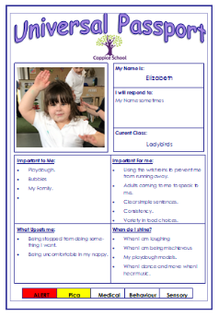
Likes/dislikes, Supporting strategies, Sensory and medical information, Communication needs and supporting strategies, PECS phase, Personal hygiene requirements, Dietary requirements and behavioural needs with supporting strategies and triggers.
Additionally, if a pupil has a specific medical need, regular medication or specific behaviours which require a support plan, these will be signposted in the passport as an additional document.
These Passports are expected to be on display discreetly in class for staff to read, new staff to look at in order to best support the pupils in class and are used to form discussion points for transition meetings.

6.3 One Page Profiles
A one-page profile is a simple summary of what is important to a pupil or young person and how they want to be supported. It can help them get more person-centred care and support to achieve their goals. A one-page profile captures all the important information about a person on a single sheet of paper.
One-page profiles are differentiated depending on the learner type (Explorer, Independent Learner & Employment Seekers). Pupils where able, have an in put into their one-page profile to capture their ‘voice’, where a pupil needs more support to share their views, staff who know them best with the support of parents helped to contribute their pupil’s views, wants and needs.

6.4 Education Health Care Plan (EHCP)
‘An education, health and care (EHC) plan is for pupil and young people aged up to 25 who need more support than is available through special educational needs support. EHC plans identify educational, health and social needs and set out the additional support to meet those needs.’ - Special Educational needs and disabilities Code of Practise 0-25 Years.
An Education, Health and Care Plan (EHCP) is a legal document, which describes a pupil’s / young person's needs. It sets out the education, health and care services needed to meet those needs and the type of educational place that would best suit the. Your pupil could have a plan from birth to 25 if he or she stays in education, and the plan will change and develop, as your pupil gets older. An EHCP focuses on identifying individual outcomes and puts pupil, young people and their families at the centre of the assessment, planning and review process.

EHCP Targets
Long Term Targets: targets that are set for a whole Key Stage this is between two and four years depending on which Key Stage the pupil is in.
Medium Term Targets: This is a one-year target linked to the long-term target.
Teachers are expected to set targets that are in line with the pupils’ provision band level and are appropriate and meaningful for the pupil.

Key Stage 1, 2 and 3 targets are set using the following headings:
- Area of focus 1 Independence
- Area of focus 2 Communication and Interaction
- Area of focus 3 Cognition and Learning
- Area of focus 4 Physical and Sensory
- Area of focus 5 Social, Emotional and Mental Health

Pupils may not necessarily have a target for each of the areas, they may have more than one target in a particular area, all targets should be set on a need basis, which will ultimately provide or build upon skills towards life after Coppice.
At Coppice we recommend that all pupils have at least one target under the ‘Communication and Interaction’

Key Stage 4 and 5 targets are set using the following headings:
- Area of focus 1 Good Health and Wellbeing
- Area of focus 2 Employability
- Area of focus 3 Friends, Relationships and Community
- Area of focus 4 Independent Living
6.5 Parental contributions and Views
Prior to an annual review meeting, parents are sent forms to ascertain their views and wishes regarding their pupil and their targets for the coming year. The class teacher will also speak to parents prior to the meetings to discuss their thoughts on targets and agree upon the ones both parties feel are important for the pupil and their development throughout the next year for medium term targets and beyond for long term targets.
6.6 Additional documentation
These are additional documents to support pupil with very specific needs, so not all pupils will have the information below as it may not be relevant to them.

- PEEP- Personal Emergency Evacuation Plan, for pupils who have difficulty leaving the building in the event of a fire alarm or emergency and need additional support or processing time in order to leave the building safely.

- Care Plan- If a pupil has additional medical needs whereby they need medical intervention, medication or close monitoring, a care plan is in place to detail their medical condition, how it affects them and any medication needed.
- Behaviour Support Plan (PBS)- Pupils who have behavioural needs which require extra support, either in class or through external agencies and have had a behaviour meeting to put in place specific strategies to support them will have a behaviour support plan.

- Medication Form – for pupils who take regular medication, or are taking regular medication for a short time such as Antibiotics, a medical form will have been completed with parental permission.
- Risk Assessments – some pupils in addition to a Behaviour support Plan will have a risk assessment in place linked to particular behaviours where either themselves or others may be at risk of harm.

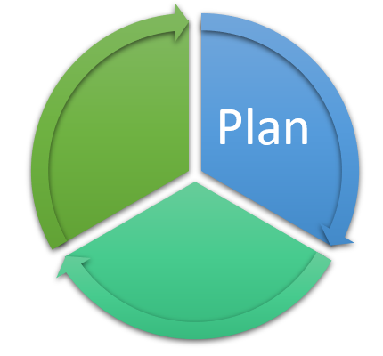

Termly Theme

7. Planning
Planning at Coppice follows a combined approach designed to promote an holistic curriculum ensuring our pupils have opportunities to develop life skills along developmental pathways, through real life and meaningful opportunities, where the world is opened up to them, to help them navigate and make sense of the world around them. By using our bespoke curriculum of colour provision bands, the activities and planning is matched to the abilities of the pupils whilst providing appropriate challenge and giving staff the knowledge to plan for their next steps in development. EHCP targets are integral to the planning process and through the No Limits approach our pupil’s voice is heard and their interests are planned for.
7.1 Long Term Overview
The long-term overview for the year provides the whole school with the Theme title per term, curriculum subject focus areas which will lead the theme and focus subsections within statutory subjects such as PE and RHSE.
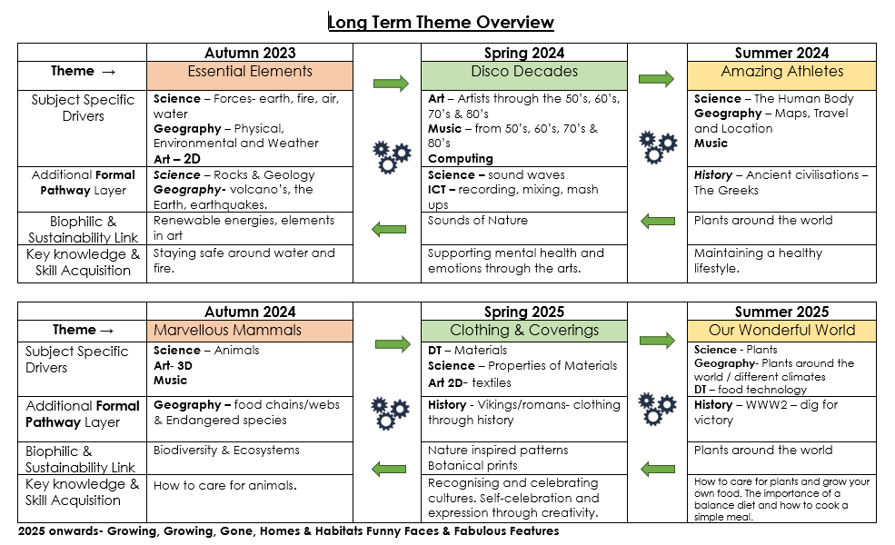

7.2 Long Terms Plans
Long term plans are currently being created to develop the breadth of expectation for each subject area, aligned to the progression maps.
7.3 Theme Overview
A Theme overview document is then created and shared with the whole school staff to provide a more specific intent aligned to learner pathways. Ensuring a shared whole school vision for the coming term with and collaborative end project. From this information, EHCP requirements, along with the understanding of which provision bands are evident with the class, staff teams should begin to formulate ideas as to how this theme will be translated and look in each class.
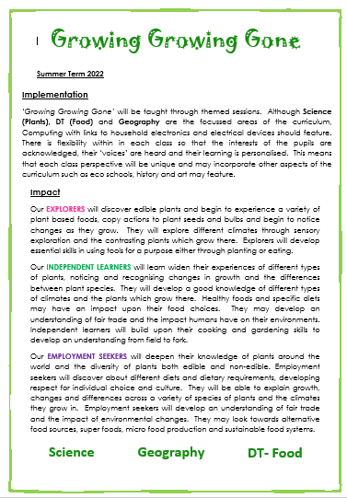
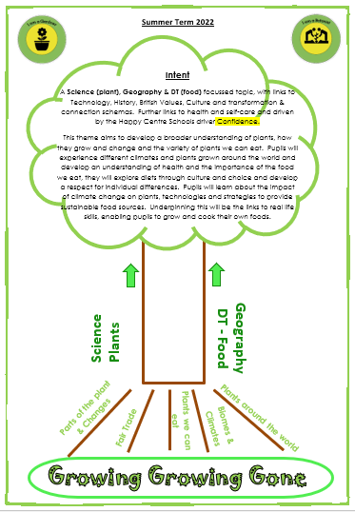

Primary & Secondary Enterprise Projects (Doncaster Primary Careers Hub)
Linked to the whole school termly theme, through discussions with our Careers Lead classes are identified to deliver upon a shared end project, which it designed to build upon skills and provide careers related learning in a meaningful context.

7.4 No LIMITs Curriculum
We believe in a broad and balanced ‘No Limits’ Curriculum that develops and nurtures
Life-Long Learning through our EHCP targets, builds
Interests, promotes
Mental health & wellbeing is
Imaginative and provides meaningful opportunities and promotes
Togetherness in the school and wider community.
It is Happy-Centred, driven by Confidence, Positive Relationships, Support, Coping Skills and Achievement and Success.

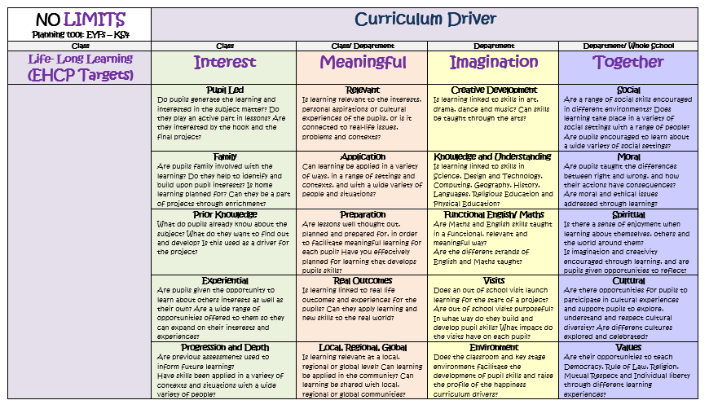

These overviews are filled in by class teams who, looking at the class as a whole aim to build the theme around the interests of the pupils in their class while ensuring the principals of No LIMITS are followed. This then forms the basis of the medium-term plans for both terms, encompassing the theme title, weaving in the key curriculum subject outcomes taken from the progression maps ensuring that planning and delivery is bespoke for each class across school.

7.5 Golden Thread
The Golden Thread refers to the key objectives linked to each of the curriculum subjects which drive the theme. These are taken from statutory documentation which are linked to the progression maps. This ensures that our pupils have a broad and balanced curriculum.
This also should be used as a basis for in the moment planning if issues arising in class, prevent planned activities from going ahead.

7.6 Medium Term Plans
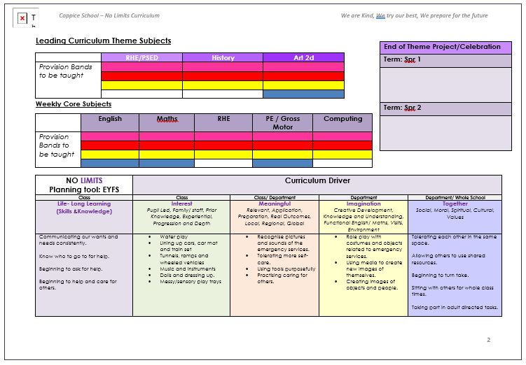
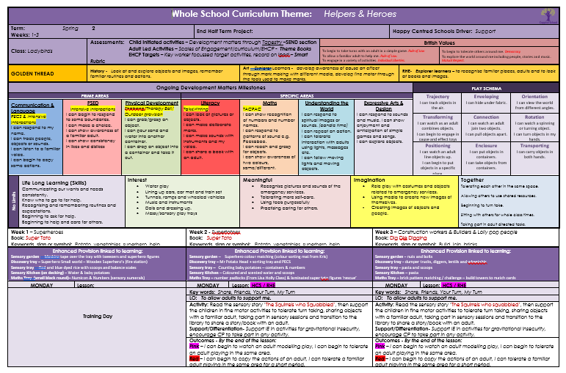
Medium term plans build on and plan for the Theme in each class, ensuring collective information from colour progression maps, the whole school theme and No LIMITs curriculum to plan for a thematic approach in each class. The theme is then delivered in a way which is meaningful to the pupils of that class. Medium term plans cover all subject/theme areas, highlight specific objectives taken from the progression maps, link in important dates, highlight the Golden thread and continuous provision opportunities.

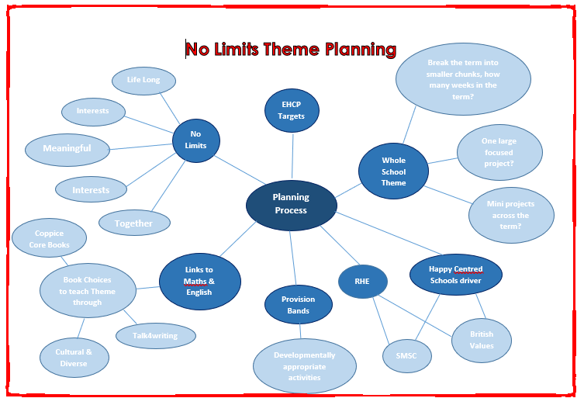

8. Overlearning, Repetition & Tinkering
8.1 Overlearning & Repetition
At Coppice we are fully aware of the value and importance of forming and keeping open neural pathways, ensuring our pupils are given time to process and reflect upon new information, given opportunities to experience the information repeatedly and over time in small manageable steps through different experiences in order to embed the knowledge and skills.
* Rosenshines Principles of Instruction and the EEF 5 a Day
8.2 Tinkering
Providing our pupils with an opportunity to ‘tinker’ at previously taught learning throughout continuous provision and at times planned for opportunities gives our pupils longer to process and explore new skills. Tinkering is new to Coppice and is something we are trialling within our maths provision.
8.3 Continuous provision
Continuous provision describes all of the different provision areas which are available for our pupils to use every day. Within each of these areas of provision there should be a range of resources that pupils can use throughout the day, these can either be linked to the whole school/class theme, to support sensory needs or support and reinforce prior learning, giving pupils the opportunities to consolidate their knowledge and skills in their own time.

9. Early Years Foundation
Although currently we do not have an EYFS Provision, previously, EYFS at Coppice follows the same/similar planning proforma and assessment reporting from Smart Rubric. From a planning perspective the colour provision bands being aligned to the SEND adaptations to Development Matters 2012 means that EYFS can align to whole school tracking and assessments, increasing the cohesion between EYFS and the rest of school, as pupils are assessed against the colour provision bands which are then translated into the development Matters Month ages and stages. For pupils who are in Foundation 2 they also have a learning journal which records their ‘Wow Moments’ on Tapestry. Their EHCP targets are tracked through Smart Rubric as with the rest of school.
See Early Years Policy

10. Post 16
Our Post 16 provision provides a bespoke curriculum across two sites (Coppice and The Bridge). Where all pupils work towards accreditation across the preparing for adulthood framework and through English and Maths. Pupils work across one of three developmental pathways to ensure they are prepared for life after Coppice.
See Post 16 Policy

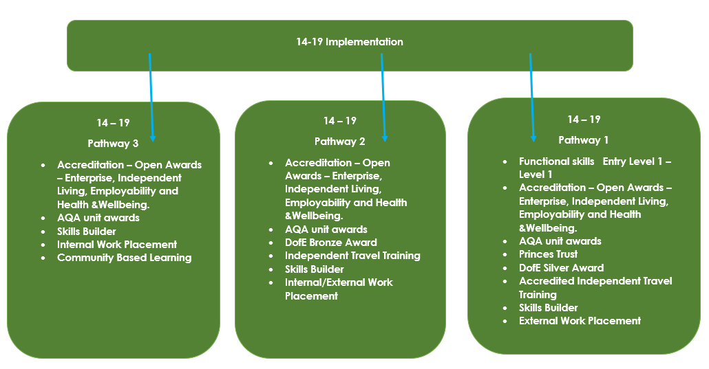

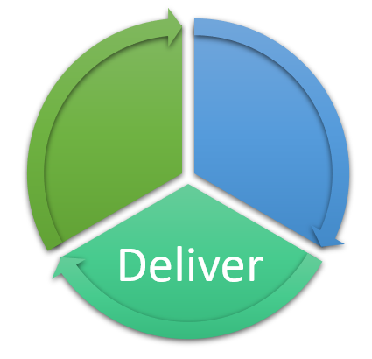
11. Curriculum Delivery
Coppice Provision Band

Coppice Pathway | Pre-Formal | Informal |  | Sem-Formal |  | Formal
Coppice Pedagogy | The Coppice approach is to deliver the curriculum in a developmentally stage appropriate way, for pupils with complex learning differences, sensory sensitivities and severe speech language and communication difficulties. Focusing on developing lifelong learning skills through meaningful and imaginative approaches and effectively integrating EHCP targets within each lesson. Flexible grouping, scaffolding, small steps, over learning and therapy are
Pedological Approaches | Play Based Learning  Enhanced Provision  Repetition  Continuous Provision  Small steps and overlearning  Sensory Therapies  PECS 1,2,3  Key word/sign and object of reference – teacher led through play  Blank level 1  Processing time  Processing time  - focus tasks for very short periods of time, end of yellow provision.  Play Schemas  Phonics Phase 1  Assessments through observations and engagement model. Feedback through gesture and sign using one key word. | Play Based Learning  Enhanced Provision  Repetition  Continuous Provision  Small steps and overlearning  Sensory Therapies  PECS 1,2,3  Key word/sign and object of reference – teacher led through play  Blank level 1  Processing time  Processing time  - focus tasks for very short periods of time, end of yellow provision.  Play Schemas  Phonics Phase 1  Assessments through a blend of observations, 1-1 plenaries and BL1 questioning. Feedback through gesture and sign using two key word. |  | Retrieval/recap  Introduction through teacher input and live modelling  Small Steps and Overlearning  Enhanced Provision (limited)  Scaffolding  Play Based Learning  Flexible groupings  Key word/sign/symbol directed through teacher input  Processing time  Paired and small group focused tasks  Blank level 2&3  PECS phase 2,3,4,5 &6  ASD strategies  Assessments through a blend of observations, small group plenaries and BL2/3 questioning |  | Retrieval/recap  Introduction through teacher input and live demonstrations  Small Steps and Overlearning  Turn- Taking Play  Co-operative Play  Reduced scaffolding  Flexible groupings  Reduced language – key words, signs, symbols and pharses.  ASD strategies to support focused learning  Phonics phase 4,5 &6 (SPaG)  PECS – Phase 4,5 &, individual PECS book and AAC device  Processing time  Small group and whole group tasks and activities.  Assessments through a blend of whole class plenaries, small group plenaries, observations and BL3/4 questioning
Phonics (ELS) and Reading
Strategies | Sensory Stories  Intensive Interaction  Story Massage  Makaton  PECS – Pre PECS and Phase 1  Talk 4 Writing repeated sensory input | Sensory Stories  Intensive Interaction  Story Massage  Makaton  Blank Level 1  PECS – Phase 2/3/4  Talk 4 Writing PECS photo/picture from book and sensory input  Physical Active Learning |  | Sensory Stories  Intensive Interaction  Story Massage  Makaton  Blank Level 2/3  PECS – Phase 4/5  Talk 4 Writing - symbol of key word/sentence strip and sensory input  Physical Active Learning |  | Blank Level 3/4  PECS – Phase 6 +  Talk 4 Writing - sentence strip/colourful semantics and sensory input  Physical Active Learning
Curriculum Coverage | Communication and Language  Physical Development- PE and Swimming  Personal Social and Emotional  Outdoor learning opportunities  Theme Enrichment  Happy Centred School and British Values  Community Visits (fortnightly)  Phase 1 Phonics  No Limits | Maths  English  Theme  Forest School  PE  Swimming  PSED  RE  Happy Centred School and British Values  Community Visits (fortnightly)  Phase 1 Phonics  No Limits |  | Maths  English  Theme  Forest School  PE  Swimming  PSED  RE  Happy Centred School and British Values  Community Visits (fortnightly)  Phase 1/2/3/4 Phonics  No Limits |  | Maths Functional Skills (KS3/4)  English- Functional Skills (KS3/4)  Theme  Forest School  PE  Swimming  PSED  RE  Happy Centred School and British Values  Community Visits (fortnightly)  Phase 4/5/6 Phonics  No Limits

11.1 Subjects to be taught

Timetable Expectation | Thematic Subjects:
Maths - 3 lessons per week | Science – Driving subject
English - 3 lessons per week | Art
Forest Schools - 1 lesson per week | Design Technology
PE - 1 lesson per week lower school  PE - 2 lessons per week upper school | Music
Swimming - 1 lesson per week | Geography
PSED/RE - 1 lesson per week | History
Happy Centred Schools and British Values - 1 lesson per week | RE
Enrichment sessions:  KS1 – Class based  KS2 – mixed classes  KS3/4 – mixed classes | A whole school termly theme consists of 3 focused subjects, Science is the driving subject throughout. Four lessons of theme are taught throughout the week.
Community visits
* This is subject to change as of September 2023 to better align with pupil pathways.

12. Classroom Environment
As a part of our drive the ensure our classrooms continue our theme of ‘Building with Biophillic Design’ in mind, ensure all displays are backed with hessian, with a black border and that all display lettering is a solid colour. Ensure when organising classrooms that our pupils need rooms which are calming and not visually overstimulating, natural and neutral colours inspired by nature are preferred. Please see the Display Policy for details.

13. Health & Safety
See the Health and Safety Policy for details.
13.1 Health & Safety in the Classroom Environment
Ensure classrooms are accessible for all pupils and allow them room to move. All broken beyond repair and unsafe furniture must be reported and removed safely. All external doors should be unlocked at the beginning of the day and locked at the end of the day and ensure all fire exits, including those in shared areas are free from clutter.
13.2 Resources
When planning activities ensure any pupils who have pica, or are likely to mouth or swallow items are very closely monitored or these items are not used and a more suitable alternative is found. Check each pupil’s EHCP for allergy awareness.
13.3 Risk Assessments
All staff must contribute to and read classroom risk assessments and ensure any classroom or pupil specific needs are added/edited on the risk assessment and stored on the shared area. These need to be reflected upon and edited as needed each term, or more frequently if issues arise which could affect the safety of pupils in class.

14. Transition & Planning Meetings
14.1 Class planning meeting
Two weeks prior to the end of each term, Teachers are expected to meet with their class teams to share and discuss the new curriculum theme for the coming term. During this meeting it is expected that support staff contribute to and understand how the theme will translate in their class, which subjects are the focus areas, what the Happy Centred Schools driver is and how the EHCP targets will be integrated to this theme and how they can support pupils to achieve outcomes along the golden thread of subjects.
14.2 Transition Weeks Overview
Transition takes place over the last 3 weeks of Summer 2 term. Once pupils have been assigned a new class for the following September and staff have then been allocated their class, pupils and teams, transition weeks are organised as follows;
Week 1 of Transition (3rd week from the end of term) New staff to spend time during the week visiting new pupils in their current classes, observing, speaking with current staff who know the pupil the best, sharing strategies, likes, dislikes etc. During protected times on an evening, new staff meet with current pupil’s class teams to read through Universal Passports, share provision band information, EHCP targets and progress towards them, family backgrounds and any other information which helps to build up a holistic picture of the pupil, including baseline assessments.
Week 2 & 3 of Transition – Pupils spend the remaining two weeks of the term in their new classes with their new class teams, to ensure September is not an unknown for all involved and pupils can settle well with staff they have some familiarity with. During these weeks new staff make contact with the parents and carers of their new pupils in order to introduce themselves and continue to build a picture of the pupils in their classes.

14.3 Transition Week Meetings Forms
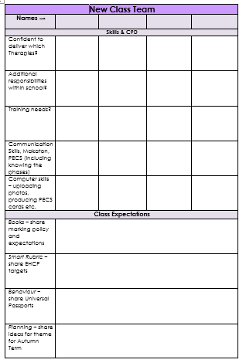
During transition weeks there are three forms which need to be completed;
- New class team form – a chance to becomes more familiar with the new staff members in the new class team, their areas of strength, support and a chance to discuss the pupils who you will be supporting for the coming year. This is also a chance to set expectations and roles within the class.

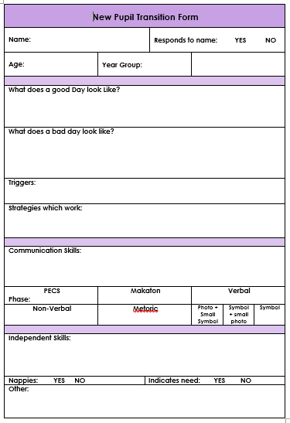
- New Pupil Transition form – this is to be completed during observations of new pupils in current classes and in discussion meetings with each pupils current class teams, in order to get to know them, strategies which work, progress towards EHCP targets and colour provision band information.

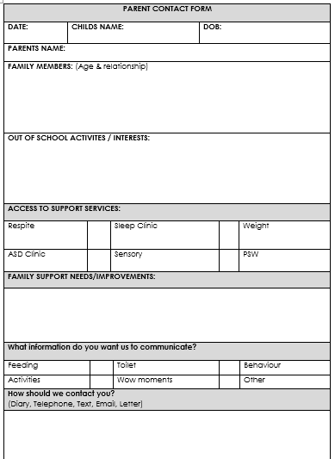
- Parent Contact form – During transition week there is also a parents evening, where parents are invited into school (or discussed over the phone if they are not able to come) to discuss their pupil and the expectations for the coming year. A chance for the new staff team to get to know the parents/carers and ask information which may help to support their pupil in the coming year.

15. Monitoring
In line with teaching standards 2,4 & 6 specifically and to support the school’s SDP and CPD needs, a cycle of monitoring takes place throughout the year.
15.1 Drop ins
Drop ins are formal lesson observations which happen twice a year in every class throughout school. Staff will be made aware of the date and time of the observation which will be conducted by one or two members of SLT. The focus for these observations will be consistent across school to enable SLT to look for trends and themes in good practise and to support further CPD. Teaching & Learning will always be a focus. Formal feedback will be given to staff as soon as is convenient.
15.2 Pop Ins
Pop Ins are informal information gathering sessions, which last no longer than 5 minutes and may or may not have a focus. The purpose of these sessions may be for subject leaders to gain an overall understanding of practise throughout school, equally they may completed by SLT to inform the SDP and develop a sound understanding of practise throughout school. These sessions are not timetabled. The feedback from these will be emailed to staff who have had a Pop in.
15.3 Pupil Outcome Review Meetings
Pupil progress meetings occur once per term, whereby a member of SLT meets with a class teacher and through a professional discussion work together to support and challenge over three main areas of inquiry – Planning, EHCP’s and Evidence/book evidence to build up a picture of pupil progress within the class. Discuss and specific issues and offer suggestions and support to further develop practise and progress in the class.
15.4 Deep Dives
Subject specific deep dives take place regularly throughout the year with Nexus support and challenge partners and external subject specialists. During the visit subject leads will be invited to discuss and share their vision, expectations and current practise across school, classes will be visited and any planning/information shared. Deep Dives aim to provide an insight into the strengths and next steps for the subject.
15.5 Coaching
Coaching sessions can take place whenever the need arises through professional discussions, as a result of monitoring, direct requests or as a supportive measure for ECT’s, new staff or to support CPD needs. These can be linked to Drop-in and Pop-in feedback.
15.6 Learning Walks or Peer Observation
Teachers and support staff are encouraged to undertake learning walks or peer observations at least once throughout the year as a means to further develop their practise and CPD.

16. Equal Opportunities
Equal Opportunities will be promoted throughout the curriculum by:
- Demonstrating that we regard all students as being of equal value.
- Getting to know each pupil as an individual.
- Allowing boys and girls access to the same activities in all areas of the curriculum.
- Treating others in a way that does not reinforce stereotypical images.
- Planning for each pupil to experience a range of opportunities.
- Maintaining high expectations of all pupils in all areas of their curriculum.
- Allowing pupils to make choices and respecting their choices.
- Celebrating difference and diversity.
- Challenging discrimination in all its forms.
- Challenging unacceptable language and providing alternatives.
- Recognising the different interests and capabilities of pupils.
- Representing the work of boys and girls of all abilities in displays.
- Reviewing resources with an equal opportunities’ awareness.

Staff & Class Assessments & Evidence Monitoring

Daily | 1:1 reading – book linked to phonics phase – recorded in reading record books.  Verbal/written or annotation feedback from planned sessions. – to be used by the class teacher to adapt or to inform next steps in learning.
Weekly | Evidence for Learning – observational assessments of pupil outcomes and achievements – linked to progression maps and/or EHCP targets Or Engagement profiles.
Half Termly | Phonics every 5 weeks – tracker updated.  Class Team Reflections – where are the pupils working within the provision bands – plan for next half term.  Update summative assessments on Evidence for Learning against EHCP targets and Progression Maps.  Check evidence for all pupils.
Termly | RAG Rate each pupil on Pupil Outcome Review document – check evidence.  Pupil Outcome Review Meetings – SLT  Update Universal Passports and one-page profiles.  Meet with class team to plan for next term – using No LIMITs Vision document.
Yearly | Annual Review document completed – link progress to evidence and summative assessments on Evidence for Learning.  Update EHCP  Reports to Parents/carers.  Transition discussion with previous class teacher.

