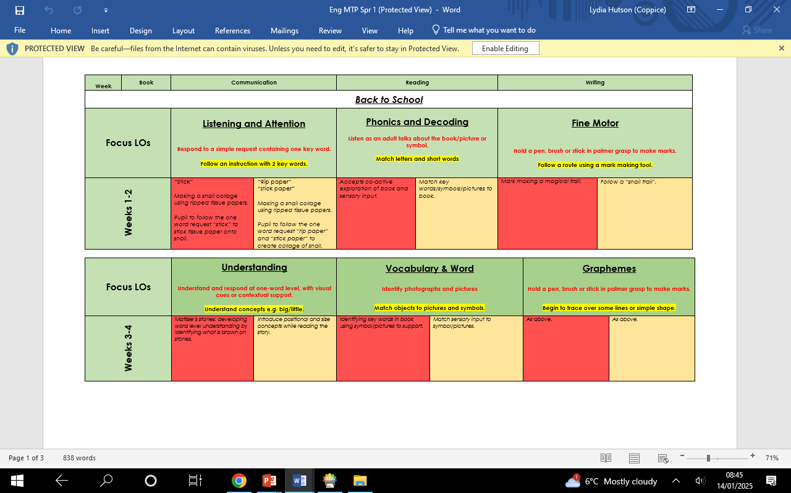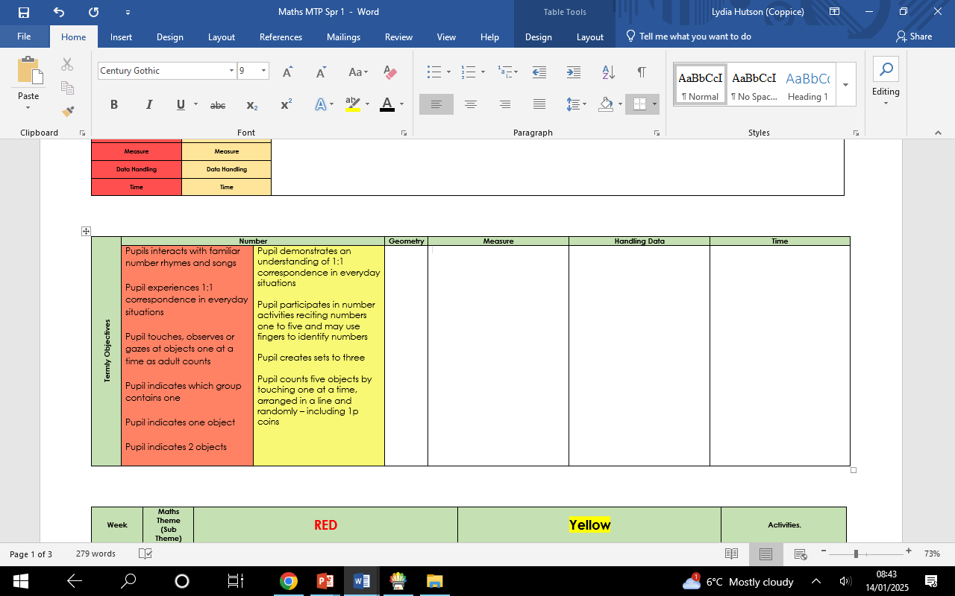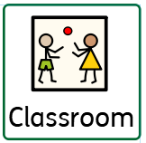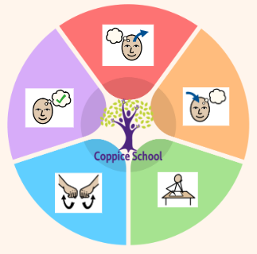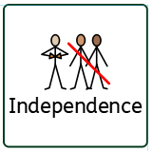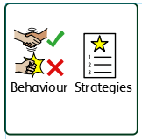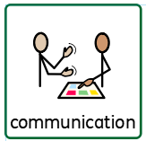

**Class: Caterpillars**

**Pathway: Informal**

**Term: Spring 1**

***In our learning environment, displays and provision we are trying to support and facilitate the following knowledge and skills;*** *communication, independence, engagement, positive interactions, self-care, trust, confidence, perseverance.*

**Composite Half Termly End Point:**

**Red:** explore self and family (and other important people around me); beginning to recognise and show interest in familiar places and people.

**Yellow:** can communicate about myself and people I know; beginning to understand language of time (later, before, now, in the future).

**Composite Half Termly End Point:**

**Red:** recognising self; able to find body parts and facial features.

**Yellow:** can find more complex body parts; beginning to notice similarities and differences with others; beginning to understand senses.

**Composite Half Termly End Point:**

**Red:** recognising and responding to emotions of others.

**Yellow:** developing methods of communication to express feelings and emotions.

**RE**

**Strand: Love and Loss**

**Composite Half Termly End Point:**

**Red:** understanding my likes and dislikes; recognising own items.

**Yellow:** recognising things that make me happy and that could help me; exploring emotions and facial expressions.

**Composite Half Termly End Point:**

**Red:** show an understanding of Yes and No; tolerating support with self-care routines.

**Yellow:** using Yes or No in response to offer of support, in particular in self-care routines.

**MY WORLD**

**Strand: Managing Feelings and emotions**

**RSE  
Strand: My changing body**

**Composite Half Termly End Point:**

**Red:** movement to music; listening to when music starts and stops.

**Yellow:** movement to music; using different parts of the body when dancing; beginning to follow a rhythm.

**Composite Half Termly End Point:**

**Red:** following simple requests (1-2 key word), developing vocabulary and recognition of symbols/pictures.

**Yellow:** developing understanding of what familiar objects are used for; following instructions; developing independence.

**Composite Half Termly End Point:**

**Red:** exploring mark making tools.

**Yellow:** Imitate drawing circles and lines.

Experiment with a range of painting techniques i.e. splatter painting**.**

**Books**:

Matisse’s Magical Trail, Faces, Cave Baby, The House Inside Mummy’s Tummy.

**Funny Faces and Fabulous Features**

***To support behaviours in our class you will see the following strategies:*** *planned ignore, 5-1 countdown, firm and consistent boundaries, gentle guiding, caring C’s, symbols, Makaton, redirect and distraction.*

**Science**

**Strand: Human Body**

**PE**

**Strand: Dance**

**DT**

**Strand: Cooking**

**ART**

**Strand: 2D**

**History**

**Strand: Changes**

**ENGLISH**

**MATHS**

***To support pupils to develop independence we encourage:*** *choosing snack, putting away and collecting own belongings, choosing adults to work with, try – try – try again.*

***To support pupils to have a voice we will use:*** *symbols, Makaton, communication boards, choose boards, I want strips, reduced language.*

**Cognition & Learning**

**Social, Emotional & Mental Health**

**Communication & Interaction**

**Physical & Sensory**

**Developing Independence**

**PSHE**