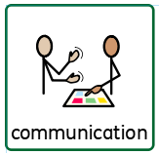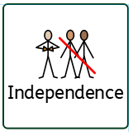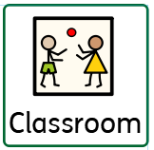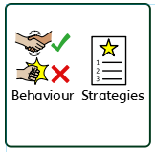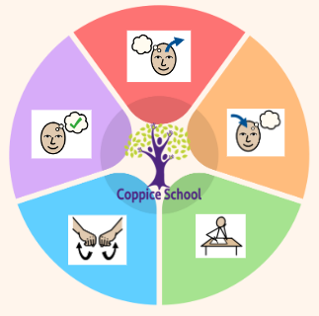

**Composite Half Termly End Point:**

**Red: Exploring relationships with the important people around me.**

**Yellow: Recognising important people around me.**

**Books: Binny’s Diwali, The Owl & the Star, I Am Peace, The Barnabus Project.**

**Composite Half Termly End Point:**

**Red: Exploring tools.**

**Theme: Cultural Celebrations**

***To support behaviours in our class you will see the following strategies: now and next, visual timetables and aids, learning first strips, planned ignore, positive handling, redirection and distraction, boundaries and expectations, positive touch, emotional coaching, therapy equipment.***

**MATHS**

***Number  
Geometry***

**Composite Half Termly End Point:**

**Red: experiences 2D and 3D shapes.**

**Yellow: match 2D and 3D shapes.**

**Composite Half Termly End Point:**

**Red: noticing similarities and differences between materials.**

**Yellow: beginning to categorise items and objects according to properties.**

**Science**

***Materials***

**DT**

***Textiles***

**Composite Half Termly End Point:**

**Red: Exploring movement and the use of equipment.**

**Yellow: Exploring movement and the use of equipment.**

***To support pupils to have a voice we will use PECs, communication boards, intensive interaction, choose boards, symbols, sign, opportunity to use voice, gesture, modelling.***

**Composite Half Termly End Point:**

**Red: Developing and building relationships.**

**Yellow: Exploring family, friends and people close to me.**

***To support pupils to develop independence we encourage: independence in dressing, personal hygiene, asking/requesting for help, use of symbols/sign/word, curiosity and bravery.***

**Composite Half Termly End Point:**

**Red: Recognising important people around me.**

**Yellow: Acknowledging and responding to the feelings of others.**

**RE**

***Respect and Tolerance***

**MUSIC**

**Composite Half Termly End Point:**

**Red: Exploration of instruments and their sounds.**

**Yellow: Exploring how movement makes sound.**

**Communication Half Termly End Point:**

**Red: developing understanding of words, symbols and signs.**

**Yellow: developing understanding of words, symbols and signs.**

**Reading Half Termly End Point:**

**Red: developing word level understanding.**

**Yellow: developing word level understanding.**

**Writing Half Termly End Point:**

**Red: exploring mark making using hands and feet (gross and fine motor).**

**Yellow: developing understanding and use of PECS (attributes).**

**ENGLISH**

***In our learning environment, displays and provision we are trying to support and facilitate the following knowledge and skills; Independence, confidence, tolerance of others, sharing and turn-taking, exploration, listening, following instruction, personal hygiene and safety.***

**Class:** Caterpillars

**Pathway:** Informal

**Term:** Autumn

**MY WORLD**

**PE**

***Ball Skills***

**Cognition & Learning**

**Social, Emotional & Mental Health**

**Communication & Interaction**

**Physical & Sensory**

**Developing Independence**

**RSE**

**PSHE**